**Energy Management System**

A modular solution for power monitoring and management for homes and small businesses

September 20, 2015

**Andrew Cope – ajc4630@rit.edu**

**Jacob Lauzon – jfl4577@rit.edu**

**Donald MacIntyre – djm4912@rit.edu**

**Ryan McLaughlin – rpm6651@rit.edu**

# Table of Contents

1 Table of Contents 2

2 Overview 5

2.1 Needs Statement 5

2.2 Objective Statement 5

2.3 Description 5

2.4 Marketing Picture 6

3 Requirements specification 6

3.1 Marketing Requirements 6

3.2 Engineering Requirements 7

4 Concept selection 8

4.1 Existing Solutions 8

4.2 System Electronics 10

4.2.1 AC to DC Conversion Concepts Considered 10

4.2.2 Surge Protection 10

4.2.3 Switching Control 11

4.2.4 Power Sensing 12

4.2.5 Controller 13

4.2.6 System Electronics Concept Selection 14

4.3 Power Line Communication 19

4.4 Web Application 21

4.4.1 Embedded Platform 21

4.4.2 Application Framework 22

4.5 Data Storage 23

4.5.1 Database Management System 23

4.5.2 Database Storage Engine 24

5 Design 25

5.1 Overview 25

5.2 System Electronics 29

5.2.1 Power Supply 29

5.2.2 Load Switch 31

5.2.3 Power Sensing 33

5.2.4 Surge Protection 37

5.2.5 Controller 38

5.3 Power Line Communication 39

5.4 Web Application 43

5.5 Data Storage 47

5.5.1 Database Model 47

5.5.2 Data Compression 48

5.6 Engineering Standards 49

5.7 Multidisciplinary Aspects 49

5.8 Background 49

5.9 Outside Contributors 50

6 Constraints and Considerations 50

6.1 Extensibility 50

6.2 Manufacturability 50

6.3 Reliability 50

6.4 Health and Safety Issues 51

6.5 Intellectual Property 51

6.6 Environmental 51

6.7 Sustainability 51

7 Cost Estimates 52

8 Testing Strategy 54

8.1 Testing Schedule 54

8.2 Unit Tests 54

8.3 Integration Tests 54

8.4 Acceptance Tests 54

8.5 Test Coverage Matrix 55

9 Risks 55

9.1 System Electronics 55

9.1.1 Power Supply 55

9.1.2 Controller 55

9.2 Web Application 55

9.3 Data Storage 56

9.3.1 Disk Space 56

9.3.2 Data Types / Values 57

10 Milestone Chart 57

11 Appendix A 59

11.1 Competitive Products 59

11.2 System Electronics 59

11.3 Power Line Communication 59

11.4 Web Application 60

11.5 Data Storage 60

12 Appendix B 61

12.1 Unit Tests 61

12.2 Integration Tests 73

12.3 Acceptance Tests 78

12.4 Test Coverage Matrix 83

# Overview

## Needs Statement

Many homeowners and businesses are not aware of their power usage habits. This lack of awareness leads to potentially inefficient power usage. Existing products are either too expensive or do not include all functionality, such as the ability to remotely control, monitor, and manage power consumption. A system is needed to allow for monitoring and basic management of a home’s or business’s power usage for a reasonable price.

## Objective Statement

The objective of this project is to design and prototype a system that will provide intuitive monitoring and control of power consumption within a residential or light commercial building. The user may track past usage data, as well as control and schedule the operation of all connected electrical loads. The outcome of the project will be the development of a limited scale proof-of concept prototype.

## Description

The Energy Management System is a system that is designed to allow homeowners and businesses to easily monitor and manage their power usage and consumption. The system consists of two main components: the main hub and many separate outlet modules. The main unit is installed at the breaker panel of the home or business and monitors overall power consumption. The outlet modules are replacement outlets for the home or business that monitor the power consumption of only that outlet. The main unit collects the usage data from all of the outlet modules and compiles the information. The Energy Management System also has a web application where all of the usage data can be viewed in graphical form. From the web application the user can also control whether each outlet module is on or off and can limit the power of each outlet. In addition, a schedule can be created to turn outlet modules on and off automatically at certain times of the day.

## Marketing Picture



Figure . Marketing Diagram

# Requirements specification

## Marketing Requirements

1. The system shall accurately monitor power consumption.
2. The system shall allow for control of whether a single gang of outlets is powered.
3. The system shall allow for a schedule to turn gangs on and off automatically.
4. The system shall be safe.
5. The system shall provide intuitive visual representations of usage data.
6. The system shall have low cost in comparison to competitive products.
7. The system shall be easy to install by a professional.
8. The system shall have an easy to use interface.
9. The system shall be of reasonable size in comparison to existing systems.
10. The system shall consume minimal power.
11. The system shall communicate usage data and commands between outlets and the main module.

## Engineering Requirements

|  |  |  |
| --- | --- | --- |
| Marketing requirements | Engineering Requirements | Justification |
| 6 | 1. Production cost shall not exceed $200 for the main unit and $50 for the outlet modules. | This is based upon analysis of a competitive market and current design requirements. |
| 7 | 1. Installation time of an outlet module within an electrical box shall not exceed 30 minutes during typical installation. | Using a professional electrician, the outlets can be installed within this time frame. |
| 4 | 1. The system shall survive a 2500V impulse voltage per IEC-60664-1. | This will prevent devices from being damaged due to transient spikes on the power line. |
| 4 | 1. Control circuits shall be isolated from power line by 1250V RMS minimum. | Electrical isolation is required by safety agencies for equipment connected to the AC power line. |
| 1 | 1. The control unit shall be capable of varying the load power from 0 to full power for resistive loads. | Dimming function allows reducing load power consumed for energy savings. This is only applicable for purely resistive loads, (e.g., lightbulbs, heaters, etc.). |
| 1 | 1. The system shall measure power consumption with an accuracy of ± 10 % | This will allow the system to measure usage accurately enough for the typical user. |
| 1,2,3,5,8 | 1. A web interface or web application shall allow the monitoring and management of the system. | This will allow a user to be able to manage the system and perform various tasks associated with the system. |
| 8 | 1. The user shall be able to understand complete system functionality within an hour. | Analysis shows that an intuitive interface should require minimal time to operate. |
| 4 | 1. The system shall use only UL recognized components. | Safety agency approvals will be required to sell product commercially. |
| 9 | 1. The system shall be able to fit into current standard electrical outlets. | To be fully integrated and competitive, the system must be able to replace current outlets. |
| 10 | 1. The system shall have greater than 95% efficiency at maximum rated load. | To achieve energy savings and to avoid excessive heating of the wall units. |
| 2,3 | 1. Wall units shall be identifiable. | This allows the system to know what information is coming from what wall unit and to provide individual control. |
| 11 | 1. All modules shall transmit at a BPS rate sufficient to relay commands and usage data at the chosen sampling frequency. | In order to have reliable communication, the modules must have an adequate minimum communication rate. |

# Concept selection

## Existing Solutions

In today’s market, there are a variety of solutions available for power usage monitoring and the scheduling and remote control of outlets and other loads (such as lights). A kill-A-Watt meter, such as the P4400, is a pass-through adapter that plugs into a single outlet, and provides advanced information about current power consumption through that outlet. The Kill-A-Watt adapter is quite large, so while it is cost-effective at only $15 per unit, it takes up multiple outlet slots (for usage data of only a single outlet), which makes it less of a full home solution. More advanced Kill-A-watt units also provide graphical analysis of power consumption. Many power companies, such as RGE, will provide web access to usage data for customers. As they have only black box access, the data available show only the power consumption for the entire building (and not per outlet). Additionally, most companies provide only average usage data for a given day, week, or month, without being able to show minute-by-minute usage data.

In the remote control (On/Off) department, radio frequency units that replace outlets inside their electrical boxes (such as WC-6015-WH at $20/unit) are another viable option. The replaced outlet gang consists of one outlet that may be controlled via a remote radio controller, and an outlet that is always on. These RF outlets provide no power measurement data, and provide only local control with the use of a remote. The Belkin WeMo units are similar in structure to the Kill-A-Watt meter, with a different feature set. The base WeMo modules ($40 and above) are adapters that plug into a wall outlet, and consume more space than a single wall outlet. These modules provide per outlet usage data, and allow the scheduling and remote operation of outlet modules. The WeMo modules do not include surge/overcurrent protection, and have no means to provide graphical analysis of the data.

Finally, complex Lutron systems are able to provide both building and per outlet power consumption data graphically, and allow for both remote and scheduled control of the loads. The primary limitation of the Lutron HomeWorks system is that it is geared almost in its entirety to the operation of only lights and shades. The chart below summarizes the various features provided by the existing solutions.

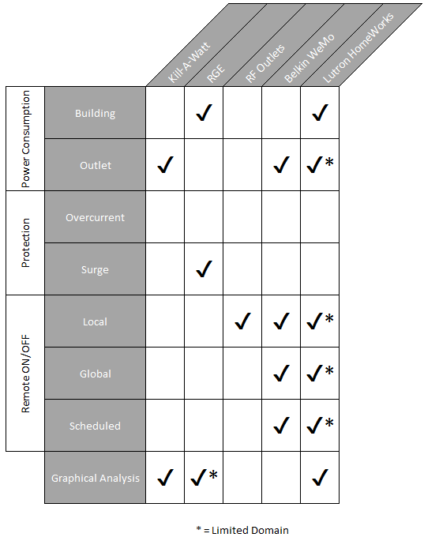

If the Lutron HomeWorks solution extended to outlets, its domain would overlap with this project. However, given its high cost and lack of outlet data and control, it is not an appropriate solution. All other modules discussed lack significant required features and are not ideal solutions. While the RF outlets are relatively simple, and could be utilized by a central unit to schedule and control outlets within a home, they would require significant modification in order to provide data acquisition and surge protection. For these reasons, the best solution is to manually create outlet modules that satisfy the project requirements.

The concept selection for the Energy Management System was broken up by sub-module such that relevant concepts could be considered for each subsystem of the Energy Management System.

## System Electronics

The system electronics were broken into the following submodules: power sense circuitry, switching control, surge protection, and AC to DC power rectification. Each submodule of the system electronics was individually surveyed.

### AC to DC Conversion Concepts Considered

There are many pre-existing power supplies to generate DC control power from the AC line, which are used in products similar to the Energy Management System. The following provides an overview of solutions considered.

#### Capacitive Coupled Circuit

Capacitive coupled circuits are common in circuits similar in scope to the Energy Management System, for example the popular Kill-A-Watt meters make use of a capacitive coupled circuit. Capacitive coupled circuits are very inexpensive as they consist of only resistors, capacitors and transistors. This type of solution is also relatively small in terms of space, which would make it ideal for a small remote unit. The downfall of this type of circuit is the limited amount of power which it can deliver to the load. Depending on the power to be delivered this may or may not be an issue. For example in the Kill-A-Watt meter the necessary power was very small and was achievable with a capacitive coupled circuit. A capacitive coupled circuit also does not provide any isolation between the digital and power signals, which can be a safety issue.

#### Linear Supply

A 60-Hz transformer along with a bridge rectifier and capacitor is a common option, which would occupy a lot of space. A transformer is also more efficient for signals faster than 60 Hz but is inefficient for a 60-Hz input. One advantage of this solution is it does provide electrical isolation.

#### Switch Mode Supply (Flyback)

Switch mode supplies convert from one voltage level to another by switching a transistor between fully on and fully off at high frequency, typically 50 to 100 kHz, ideally dissipating no power. The output voltage is regulated by the duty cycle, ratio of on time to switching frequency. A high frequency output filter converts the switched waveform to DC, determined by the average value of the switching. Switch mode supplies are more efficient than a linear supply and are often smaller since they do not require a 60Hz transformer. Switch mode supplies also can be purchased as dedicated integrated circuits, which require only a handful of external components. Electrical isolation can be provided by using small high frequency transformers, (e.g., flyback converter).

### Surge Protection

Surge protection is needed in modern electrical appliances to protect devices from voltage spikes. Typical voltage spikes, which can be caused by lightning, can damage electronics. Therefore, it is important to implement a method of minimizing transient currents and voltages seen by sensitive electronics. Important specifications, which typically define surge protectors, are clamping voltage, or the voltage at which unwanted energy is protected from the line, joule rating, which specifies how much energy can be absorbed without failure, and response time, which indicates how fast a device is able to respond in the presence of a spike. Several methods of surge protection are outlined below.

#### Gas Discharge Tube (GDT)

GDTs consist of a device with an enclosed gas, which conducts at certain voltage level. They are able to handle more current than other devices of similar size but have a short life expectancy and are only able to handle only a small number of large transients. GDTs also have a slow response time, and additional suppression components are often needed to fully protect loads.

#### Transient Voltage Suppression (TVS)

TVS solutions provide the fastest response time to voltage spikes but are able to absorb the least amount of energy. Failure of TVS solutions can lead to a permanent short circuit, which results in the bus’s being shorted out. TVS circuits are used most frequently in high-speed low power applications such as digital logic.

#### Metal Oxide Varistor (MOV)

MOVs have a low life expectancy when exposed to many transients, and after failure occurs, a partial or complete short circuit can exist. MOVs can become very hot if a failure occurs, and it is often necessary to connect a MOV with a thermal fuse to prevent thermal runaway, which leads to fires and explosions. However, MOVs are the most common surge protector in AC electronics due to their low cost and reasonably good performance. UL recognized MOVs are frequently used in power line surge protection applications.

#### Thyristor Surge Protection Device (TSPD)

A TSPD switches to an on state once a voltage threshold is exceeded with a high current capability of up to 200A. TSPDs have no effect on a circuit during normal operation, and similar to an MOV conduct only during the on state. The on state is triggered by a transient voltage that exceeds the voltage threshold of the device. TSPDs provide high surge current ratings and low device capacitance. TSPDs are used in AC applications, which require high surge current handling. They are not typically found in household appliances.

### Switching Control

#### TRIAC

A TRIAC is a PNPN thyristor semiconductor, which is able to conduct current in both directions when it is turned on. TRIACs are commonly used for AC phase control. TRIACs are non-isolated devices, and opto-isolation of the TRIAC gate drive signal would be needed to provide isolation of control circuits from the AC line. To turn on a TRIAC, it is necessary to apply a positive or negative current to the gate with respect to the main terminal. TRIACs are frequently used in AC switching applications due to their ability to control large currents with small gate current pulses. After triggering via a gate pulse, TRIACs latch on independent of the gate pulse. The line current must go to zero by external means for the TRIAC to turn off. TRIACs can also be false triggered on via high rates of voltage change across their main terminals. Therefore an RC snubber circuit is needed to prevent the TRIAC from turning on due to a voltage transient on the main power line causing a large dV/dt value between the two main terminals of the device. TRIACs are commonly used in light dimmers, and small electrical motors due to the ability to perform bidirectional phase control. Phase control involves sensing the AC line zero crossing and then waiting for an adjustable phase delay before triggering the TRIAC on to control the voltage applied to the load.

#### Relay

A relay is an electromechanical device which functions as a switch. Relays consist of a magnetic winding or coil, which generates a magnetic field when current is passed through it. The field moves an arm of a contact to make or break an electrical connection. The relay coil is electrically isolated from the output contacts. Relays have a delay, on the order of milliseconds, between command and result due to the physical nature of the relay. Relays are available in a wide range of physical sizes and current handling capability, and versions are available for both DC and AC switched circuits. They are a cost effective solution for AC on/off switching, but they cannot provide variable voltage control such as needed for lamp dimming.

#### Transistor

A transistor solution can be realized using BJT or MOSFET transistors. In order to accomplish AC switching, a diode bridge will need to be constructed, with the transistor in the center of the bridge. The diode bridge is required to make the unidirectional transistor capable of controlling AC currents. Also a continuous gate drive is necessary when the switch is to be on. The advantages of a transistor configuration is switching can occur at a high frequency to provide variable load power. Like a TRIAC, a transistor would require an isolated drive signal to provide isolation between the control and power circuits. The diode bridge required would increase physical size and semiconductor power losses versus the TRIAC solution. Unless there is a need for high frequency switching the TRIAC is a better load switch for phase control applications.

### Power Sensing

Power sensing needs can be broken into two aspects: current and voltage sensing. A controller will then use the current and voltage measurements to determine various metrics, such as but not limited to average power dissipated, power angle, etc.

#### Current Sensing

##### Sampling Resistor

A low ohm resistor can be put in series with the current to sense, and the voltage across the resistor can be measured. Since the value of the resistor and the voltage drop is known, the current can be determined using Ohms law. A sampling resistor does have a small effect on the load since a small resistor is being added in series with the load. A sampling resistor will also dissipate power. In order to achieve an accurate measurement the sampling resistor must have a tight tolerance.

##### Hall Effect Sensor

A Hall effect IC sensor can be used to measure current. Any wire with current traveling through it produces a perpendicular magnetic field. A hall sensor is able to measure the magnetic field and produce an output voltage in relation to the magnetic field. Digital Hall sensors are often used in position sensing applications specifically to determine the rotor position referenced to a stator. Analog Hall sensors are often used in current sensing applications. Many prepackaged Hall effect current sensors are available. These sensors have the advantage of providing electrically isolated current sensing with no power loss.

##### Integrated Circuit

An integrated circuit performs current sensing by running the current to be measured into the IC. The integrated circuit typically produces an output such as an analog voltage proportional to the sensed current that can be fed into an ADC and processed by a controller. These current sensing integrated circuits are typically based on Hall effect sensing. They have the advantages of larger Hall effect sensors.

#### Voltage Sensing

A voltage sensor detects the amount of voltage and generates a proportional output signal relative to the sampled voltage. Several possible implementations are examined.

##### Differential Amplifier

Differential amplifiers amplify differential signals, and reject signals common to both inputs. By choosing the input and feedback resistors a gain can be obtained such that the sensed voltage is scaled to a range, which can be processed by an ADC. Knowing the gain of the differential amplifier, a controller can determine the input voltage. A differential amplifier does not provide electrical isolation, and therefore with this particular solution the power electronics are isolated only from the control electronics by high impedance. A differential amplifier used for line voltage sensing would have large voltage dividers with very high input resistances to scale the line voltage down to the 3- or 5-volt range required for a microcontroller.

##### Optical Isolator

An optical isolation amplifier IC is used to produce an output voltage which is proportional to the input voltage on the other side of the optical isolation barrier. Several optical isolation solutions exist, from simple input LEDs optically coupled to photo diodes or phototransistors to complex ICs with primary and secondary control integrated circuits that then transmit digital signals optically across the isolation barrier. The input voltage is typically resistively divided down such that it is in a pre-defined range of for example 0 to 2V as required by the ACPL-C870-000E part manufactured by Avago.

### Controller

A number of manufactures offer low cost microcontrollers intended for electronic watt-hour meter and smart grid applications. Several offer evaluation boards and embedded software for energy management. The main functions of the controller will be to acquire the AC current and voltage values in real-time, perform instantaneous power calculations, determine zero crossings, control the load switch, calculate the voltage to current phase angle, calculate the line frequency, send data through the power line communication interface, and provide overcurrent load shutdown. It is also desirable for the controller to be low power and low cost. The availability of proven design tools and evaluation boards is a factor in controller selection. A minimum of two onboard ADCs is necessary to handle voltage and current conversions. Ideally the two ADCs are able to sample simultaneously. Timers are also necessary to perform frequency calculations. I/O is also needed to allow for status LEDs and load switching. The controller to be selected is highly coupled with the on-going power line communication (PLC) investigation, and therefore controller requirements are subject to change relative to what may be discovered from this separate investigation. An I2C serial link is required for interface to the PLC module.

#### Texas Instruments – MSP430 Low Power Family

The MSP430 family is a 16-bit microcontroller designed for low cost, and low power applications. The MSP430 base microcontroller provides a 16-bit multiplier, a 16-bit timer, 3 sigma-delta converters (ADCs) which have a dynamic range of 1:2400. Serial interfaces of UART and SPI are also provided which can run at 8-MHz. Eleven I/Os are also available for various applications. The MSP430 also has a small footprint as it comes in a package of 24 pins at a size of 35-50 mm. Development boards and software, including example code, are provided by Texas Instruments. An extensive library of energy metering functions exists and is publicly available.

#### Peripheral Interface Controller (PIC) – PIC16F873A

The PIC16F873A manufactured by Microchip is an 8-bit microcontroller with 5 channels of 10-bit ADC and a synchronous serial port capable of SPI or UART protocols. The PIC comes in a 28-pin package thus allowing it to fit nicely on a small PCB. MPLAB® development tools are also available to support the PIC microcontroller family. The device has been used in power meter applications, and design examples are available.

#### STMicro – STPMXX Family

The STPM family is a group of ICs designed specifically for the application of the measurement of energy in a single-phase system. The STPMXX is highly customized to accomplish the task of energy detection, and therefore additional processing power may be necessary to handle the power line interface circuitry. A good library of energy metering functions exists and is publicly available.

### System Electronics Concept Selection

In order to determine the concept selection that best meets the desired functionality Pugh tables were generated. Due to the nature of this investigation, some sub-modules have multiple valid possibilities, and certain uncertainties still exist. The Pugh selection criteria rated design concepts on key characteristics and assigns a +, 0, or – rating for each criteria relative to the other concepts. The ratings are then tallied to rank the different concepts relative to each other. While it is possible to assign different weights to the selection criteria based on their relative importance, in this analysis a simple unweighted approach was used.

#### Power Supply

The Pugh table for the AC to DC power supply is shown in Table 1.

Table . Pugh Concept Selection for Power Supply

|  |  |  |  |
| --- | --- | --- | --- |
|  | **Concepts** | | |
| **Selection Criteria** | **Capacitive Coupled Circuit** | **Linear Supply** | **Switch Mode Supply** |
| **Power Delivered** | 0 | + | + |
| **Isolation** | - | + | 0 |
| **Size** | + | - | + |
| **Cost** | + | - | - |
| **Positive** | 2 | 2 | 2 |
| **Neutral** | 1 | 0 | 1 |
| **Negative** | 1 | 2 | 1 |
| **Net Score** | 1 | 0 | 1 |
| **Rank** | 1 | 2 | 1 |
| **Continue** | Yes | No | Yes |

After performing a Pugh analysis, it was determined that both a switch mode supply and a capacitive coupled supply are feasible. A switch mode supply is an easier and more direct solution, but it is much more expensive and takes up more space than a capacitive coupled circuit. Due to the high cost of the switch mode supply, it would not be considered for a production environment, and a capacitive supply comparable to those used in other similar products such as the Kill-a-Watt meter would be used. However, for the first iteration of this project a packaged switch mode controller made by Recom will be selected as it mitigates this risk, at the expense of cost, and will allow the development team to focus on other risks which are not as easily mitigated. A second iteration may be developed with a capacitively coupled power supply, which will provide a vast reduction in cost per unit.

#### Surge Protection

The Pugh table for the surge protection function is shown in Table 2.

Table . Pugh Concept Selection for Surge Protection

|  |  |  |  |  |
| --- | --- | --- | --- | --- |
|  | **Concepts** | | | |
| **Selection Criteria** | GDT | TVS | MOV | TSPD |
| **Cost** | - | 0 | + | 0 |
| **Energy Dissipated** | + | - | 0 | + |
| **Response Time** | - | + | 0 | 0 |
| **Clamping Voltage** | 0 | 0 | 0 | + |
| **Length of Life** | - | - | + | 0 |
| **Positive** | 1 | 1 | 2 | 2 |
| **Neutral** | 1 | 2 | 3 | 3 |
| **Negative** | 3 | 2 | 0 | 0 |
| **Net Score** | -2 | -1 | 2 | 2 |
| **Rank** | 4 | 3 | 1 | 1 |
| **Continue** | No | No | Yes | No |

After performing a Pugh analysis, the MOV and TSPD concepts tied. It was determined that the varistor (MOV) will be placed between line and neutral to handle power surges, because it is the more common solution used in household appliances.

#### Load Switching

The Pugh table for load switching is shown in Table 3.

Table . Pugh Concept Selection for Load Switching

|  |  |  |  |
| --- | --- | --- | --- |
|  | **Concepts** | | |
| **Selection Criteria** | TRIAC | Relay | Transistor |
| **Cost** | 0 | 0 | 0 |
| **Switching Speed** | + | 0 | + |
| **Isolation** | 0 | + | - |
| **Interfacing** | 0 | 0 | - |
| **Power Dissipated** | + | - | 0 |
| **Phase Control** | + | 0 | 0 |
| **Positive** | 3 | 1 | 1 |
| **Neutral** | 3 | 4 | 3 |
| **Negative** | 0 | 1 | 2 |
| **Net Score** | 3 | 0 | -1 |
| **Rank** | 1 | 2 | 3 |
| **Continue** | Yes | No | No |

Based on the results of Pugh analysis, a TRIAC was selected as the concept to be implemented for load switching.

#### Power Sensing

Power sensing was divided into two sub-tasks: current and voltage sensing. With instantaneous current and voltage characteristics, the chosen controller will be able to perform all necessary power calculations.

##### Current Sensing

The Pugh Table for current sensing is shown in Table 4.

Table . Pugh Concept Selection for Current Sensing

|  |  |  |  |
| --- | --- | --- | --- |
| Current Sense | | | |
|  | **Concepts** | | |
|  | Sampling Resistor | Hall Effect Sensor | Integrated Circuit |
| **Effect on circuit** | - | + | + |
| **Accuracy** | - | 0 | + |
| **Cost** | + | 0 | 0 |
| **Positive** | 1 | 1 | 2 |
| **Neutral** | 0 | 2 | 1 |
| **Negative** | 2 | 0 | 0 |
| **Net Score** | -1 | 1 | 2 |
| **Rank** | 3 | 2 | 1 |
| **Continue** | No | No | Yes |

Based on the results of Pugh analysis, an integrated circuit was selected as the concept to be implemented for current sensing.

#### Voltage Sensing

The Pugh Table for voltage sensing is shown in Table 5.

Table . Concept Selection for Voltage Sensing

|  |  |  |
| --- | --- | --- |
|  | **Concepts** | |
| **Selection Criteria** | Differential Amplifier | Optical Isolator |
| **Accuracy** | 0 | 0 |
| **Cost** | + | - |
| **Interfacing** | 0 | 0 |
| **Isolation** | 0 | + |
| **Linearity** | + | 0 |
| **Positive** | 2 | 1 |
| **Neutral** | 3 | 3 |
| **Negative** | 0 | 1 |
| **Net Score** | 2 | 0 |
| **Rank** | 1 | 2 |
| **Continue** | Yes | No |

Based on the results of Pugh analysis, a differential amplifier was selected as the concept to be implemented for voltage sensing.

#### Controller

The Pugh Table for controller selection is shown in Table 6.

Table . Concept Selection for Controller

|  |  |  |  |
| --- | --- | --- | --- |
|  | **Concepts** | | |
| **Selection Criteria** | TI MSP430 | STMicro | PIC |
| **Cost** | + | 0 | + |
| **Size** | + | + | + |
| **Development Tools** | + | - | 0 |
| **Development Time** | 0 | 0 | 0 |
| **Interface** | 0 | 0 | 0 |
| **Positive** | 3 | 1 | 2 |
| **Neutral** | 2 | 3 | 3 |
| **Negative** | 0 | 1 | 0 |
| **Net Score** | 3 | 0 | 2 |
| **Rank** | 1 | 3 | 2 |
| **Continue** | Yes | Yes | Yes |

Based on the results of Pugh analysis, a TI MSP430 family microprocessor was selected as the processor to use as the controller. However, due to unknown impact of power line communications, continued investigation of the controller choice is expected.

## Power Line Communication

In order to simplify user setup, to avoid concerns with obstacles such as walls in unknown environments, and to avoid saturating clients’ routers with power usage data, power line communication was chosen to communicate between the outlet modules and the main module, which will accumulate power usage data. For operation within a large building, three-phase power would be a concern for this communication. In such a situation, three communication modules may be necessary to ensure the main module is able to communicate with all of the remote outlet modules. However, for the scope of a typical home sized prototype, it is assumed that the modules will all be in phase.

As a mature technology, power line communication (PLC) chips are relatively simple to utilize, and will take care of many of the complex facets of communication automatically. Some of the concerns associated with PLC are interference, data rates, collision handling, and interfacing with the chip. The majority of interference on the main lines of a home occurs at low harmonic frequencies of the base frequency of 60 Hz. The majority of PLC chips account for this by utilizing a much higher frequency than 60 Hz to avoid the issue entirely. While it is possible to manually implement a collision handling protocol, it is far more desirable to purchase a PLC chip with integrated collision handling.

As the communication rate for many modules is specified in a bps format, including the package’s header and other transmission information (CRC error detection/repair bits, etc), the necessary transmission rate will depend on the chosen chip. As an estimate, the transmission rate, in bits/sec must at least meet this requirement:

**(1)**

Where B, M, P, D, and Fs are respectively the minimum supported bitrate of an adequate chip [bits/second], the number of outlet modules, any non-data transmission information (such as packet headers, CRC bits, etc), the number of actual data bits per transmission, and the sampling frequency of a single module. Note that this is merely a minimum requirement – sending commands from the main module will add further data requirements but will be considerably less frequent, and so was not included here. Additionally, resending of data may also impact the necessary transmission rate, but is chip dependent.

Based on Equation 1, if the packet sent consisted of only an 8-bit ID (identifying the outlet out of 200 outlets) and a 14-bit (accurate to 1 mA) power consumption, sampling in real-time at 10 transmissions/second, then the required data rate would be 44000 bits/second. This means for these calculations, any feasible chip would have a transmission rate considerably over 44000 bps. A selection of chips, including chips from STMicroelectronics and Cypress, were then analyzed using this low estimate process, as shown in the chart below. This chart also includes information about the interface utilized for each chip. The column marked “Collision Provisions” indicates whether the chip has collision handling capabilities.

Table . Power Line Communication Chip Selection Chart

|  |  |  |  |  |
| --- | --- | --- | --- | --- |
| Part | Packet Bits | Provided Data Rate | Collision Provisions | Interface |
| CY8CPLC10 | 56 | 2400 | Yes | I2C |
| CY8CPLC20 | 56 | 2400 | Yes | I2C, UART |
| ST7540 | 0 | 4800 | No | UART,SPI |
| ST7570 | 112-336 | 2400 | Yes | UART |
| ST7590 |  | 128000 | Yes | UART,SPI |
| MAX2992 |  | 300000 | Yes | UART,SPI |
| ATSAM4CP16B |  | 128000 | Yes | UART,SPI |
| TDA5051A | 0 | 1200 | no | Digital |

The results of the comparison are namely that there are two categories of chips being considered. The first category of chips are relatively simple, with few pins, a bigger chip area, and a slower data rate; including chips such as the CY8CPLC10, CY8CPLC20, ST7540, ST7570, and TDA5051A. These chips are less expensive but have an insufficient data rate considering the estimation made using Equation 1.

The second category of chip has a smaller surface area with a higher density of pins, usually incorporating a method to handle collisions, and even provide programmability. Many of these chips have 50 or 100 pins, which make them a concern for routing on a PCB.

Based on these considerations, the primary decision was to utilize a “simple” chip that also handles collisions, if the data rate can be reduced enough to allow it to be used. If the data rate is not reducible, then a more complex and expensive chip must be utilized. For the purpose of the analysis, the Cypress CY8CPLC10 was chosen, although it in no way guarantees that it is the final component chosen.

## Web Application

There were two main concepts that needed to be considered when thinking about building the web application. The first was which embedded platform to use and the other was how to serve (or host) the application and which, if any, framework to use to aid in the building of the application. Both of these elements were important and would affect the overall design and functionality of the application. When deciding which embedded platform to use and how to serve the application, each element was looked at separately and a separate decision was made for each.

### Embedded Platform

When considering the embedded platform it was first decided that the project requires a platform that is very easy to set up and get connected to the network, has enough computing power to serve a fluid application and host a database, is easy to develop on and make changes to, and is relatively small and low power. We decided to go with an embedded platform that runs a variation of Linux to allow for the ease of setup, computing power, and flexibility. This narrowed the search down to two competing products, the BeagleBone Black and the Raspberry Pi 2. Both of these platforms are very powerful and run a Linux distribution. Both also come with some trade-offs such as being larger than a standard microcontroller, consuming more power than a typical microcontroller, and having more overhead because of the Linux distribution. Despite these drawbacks, it was decided that one of these devices would be best for what was needed. The two choices were then examined closely to decide on the best one. Table 8 shows a comparison of the specifications of both of these devices.

Table . Comparison of Embedded Platforms

|  |  |  |
| --- | --- | --- |
| **Product** | **Raspberry Pi 2 Model B+** | **BeagleBone Black Rev C** |
| **Price** | $35 | $55 |
| **Size** | 3.370" x 2.224" | 3.4" x 2.15" |
| **Processor** | Broadcom BCM2836 | AM3358BZCZ100 |
| **Cores** | 4 | 1 |
| **Clock Speed** | 900 MHz | 1 GHz |
| **RAM** | 1 GB | 512 MB |
| **Onboard Flash** | None | 4 GB |
| **External Storage** | microSD | microSD |
| **Operating Voltage** | 5V | 5V |
| **Power** | 230 - 800 mA | 210 - 460 mA |
| **Digital GPIO** | 40 | 65 |
| **Analog Inputs** | None | 7 |
| **I2C** | Yes | Yes |
| **SPI** | Yes | Yes |
| **Ethernet** | 10/100 RJ45 | 10/100 RJ45 |
| **USB** | 4 | 1 |
| **Video Out** | HDMI | micro HDMI |

After looking at the comparison of the two units, the choice was clear. The **Raspberry Pi 2 was chosen** as the embedded platform. The most significant reason for the choice was the cost. Both devices perform similarly and have similar specifications in most areas so a $20 price difference made the Pi the obvious choice. The Pi also has double the RAM of the BeagleBone, which made it an even better fit. The device will have to host a web application, a database, and the Linux distribution so more RAM will be beneficial. The Pi does lack in digital I/O and analog inputs when compared to the BeagleBone, but the main unit will not require many inputs so the Pi will perform just fine. Both devices have Ethernet, USB, and some communication buses so, again, the cost of the Pi was the deciding factor. In addition to the specifications, both devices were tested for their ease of use. The simple task of loading the Linux distribution and installing some basic software on both devices was performed. From this subjective test, the Pi was easier to setup and work with than the BeagleBone, providing yet another positive for the Pi.

### Application Framework

The other important element to consider for the web application was the application framework that is going to be used to build the application. The framework that is used will determine how the application looks, how the application runs, and how the application will be developed. It was very important to choose the correct framework that would help achieve a clean looking and fluid web application and allow for ease of setup and development. There are many different application frameworks in different programming languages that can accomplish a whole suite of different tasks. When searching for the right framework many different aspects were evaluated, including the memory consumption, the programming language used, the documentation, the ease of setup, and the flexibility. The many different choices were narrowed to just three that were looked into more closely: a Java implementation, a Django implementation, and a HTML, JavaScript, and PHP implementation. A summary of these three frameworks can be seen in Table 9.

Table . Comparison of Frameworks

|  |  |  |  |
| --- | --- | --- | --- |
| **Framework** | **Java Application** | **Django** | **HTML/JavaScript/PHP** |
| **Idle Memory Consumption** | ~150 MB | 20-30 MB | ? |
| **Language** | Java | Python | HTML/JavaScript/PHP |
| **Documentation** | 5 | 4 | 5 |
| **Ease of setup (5 = easiest)** | 4 | 3 | 5 |

Table 9 shows some of the information that was considered about each framework. A very rough memory test was run for Java and Django. A basic server was set up to run a boiler-plate web application with each framework, and the memory consumption was recorded. This test was not run for the HTML/JavaScript framework because of the variability in memory consumption of different JavaScript libraries, hosting methods, and many other factors. For each framework, a subjective score was determined for the documentation and the ease of setup. All three frameworks had very good documentation, with Django lagging slightly because it is a newer framework. After considering all these factors and others as well, it was determined that both Django and Java were both good choices. It was decided that a **Java application would be best**. The main reason for the choice was the team’s familiarity with Java web applications. Members of the team have worked with Java web applications in the past, so it was decided it would be more time efficient to use Java. The greater memory usage of the Java application should not cause a problem as the Raspberry Pi should have enough memory. A Java application will also be more powerful in terms of a graphing and scheduling interface.

## Data Storage

The power consumption readings from each of the outlet modules must be stored, so they may be accessed at any time through the web application. The most appropriate method of storing information is in a database, which is accessed with a database management system.

### Database Management System

Several factors were examined in order to determine which database management system (DBMS) was appropriate. The first was the operating system on which the DBMS would run. The second was the licensing available through each DBMS, to determine if money would need to be spent. The third factor was the variety of available programming languages, specifically the ones used in the main unit. A fourth, but lesser factor, was the data type variety that could be stored in the database. The Pugh analysis table, seen below in Table 10, was used to determine the most appropriate DBMS solution. A +1, -1, and 0 represent the solution is desirable, undesirable, and not applicable, respectively.

Table . Pugh Analysis on DBMSs

|  |  |  |  |  |
| --- | --- | --- | --- | --- |
| **Solution** | **Microsoft SQL Server** | **MySQL** | **PostgreSQL** | **SQLite** |
| **Windows Server OS** | -1 | 0 | 0 | 0 |
| **Linux OS** | 0 | +1 | +1 | +1 |
| **Commercial License** | -1 | 0 | 0 | 0 |
| **Open Source License** | 0 | +1 | +1 | +1 |
| **Supports Java** | +1 | +1 | +1 | +1 |
| **Supports PHP** | +1 | +1 | +1 | +1 |
| **Supports Python** | +1 | +1 | +1 | +1 |
| **Sufficient Data Types** | +1 | +1 | +1 | -1 |
| **Total Rating** | 2 | 6 | 6 | 4 |
| **Rank** | 4 | 1 | 1 | 3 |

According to Table 10 above, Microsoft SQL Server came last in the overall rankings. This was due to its availability only on the Windows Server OS platform, as well as its need for a commercial license. This was undesirable, due to the main unit having a Linux-based embedded platform. SQLite came third in the rankings, due to its lack of desired data types supported. While managing the readings and outlet modules could be achieved using the primitive data types, it would be easier from a development standpoint to have more advanced data types. MySQL and PostgreSQL were both placed first in the rankings, as their criteria met all of the requirements for the Energy Management System. MySQL was chosen as the database management system.

### Database Storage Engine

There are several storage engines for MySQL, all of them performing similarly to accomplish the same tasks: creating, reading, updating, and deleting data from a database. The Pugh analysis in Table 11 shows the comparison of several storage engines, and analyzes them to choose the most appropriate solution for the MySQL DBMS.

Table . Pugh Analysis on MySQL Storage Engines

|  |  |  |  |
| --- | --- | --- | --- |
| **Solution** | **Memory** | **InnoDB** | **MyISAM** |
| **Reliability** | -1 | +1 | +1 |
| **Row-level Locking** | +1 | +1 | -1 |
| **Table-level Locking** | 0 | 0 | +1 |
| **Read-heavy Performance** | +1 | 0 | +1 |
| **Write-heavy Performance** | +1 | +1 | -1 |
| **Transaction Support** | +1 | +1 | 0 |
| **Storage Medium** | -1 | +1 | 0 |
| **Total Rating** | 2 | 5 | 1 |
| **Rank** | 2 | 1 | 3 |

As seen in Table 11 above, InnoDB is the most desired choice for the storage engine. Memory came second; however, it was undesirable due to its storage medium and reliability. As the name suggests, all of the tables in the database are stored in memory. Once enough changes have been made, the database is then flushed to disk. However, if the main unit lost power, any readings or changes not flushed to the storage device would be lost. InnoDB and MyISAM update the file on the storage device after every query. Row-level locking is important, as it allows the table to be written even when a certain row is locked. MyISAM supports only table-level locking, which could potentially cause backups, as the outlet readings could not be written to until the table is unlocked. This leads to poor write-heavy performance, which could occur if multiple real-time readings were taking place.

# Design

## Overview

The Energy Management System is a system designed to allow for monitoring and management of power usage with the objective of providing energy conservation for a home or small business. The system provides an easy method of monitoring, managing and controlling power consumption of all connected electrical loads. The system consists of two main components, the main unit and separate outlet modules. The main unit is installed at the breaker panel of the home or business. It monitors overall power consumption, collects usage data from the outlet modules, and compiles the information. The Energy Management System also has a web application where all of the usage data can be viewed in graphical form. From the web application, the user can control whether an outlet module is on or off, and can limit its power. In addition, a schedule can be created to automatically turn outlet modules on and off at certain times of the day. The outlet modules are replacement outlets for the home or business that monitor and control the power consumption of only that outlet as directed by the main unit. Figure 2 shows a high level diagram of the Energy Management System.



Figure - High-Level System Diagram

The main unit will be composed of two principal hardware components. The main control unit, shown functionally in Figure 3, consists of the master controller, data storage, and communication interfaces. The breaker-monitoring unit, shown functionally in Figure 4, consists of the main breaker power sensing and power line communication functions.



Figure - Main Unit Functional Diagram

The remote outlet module, shown functionally in Figure 3, consists of current and voltage sensing, power commutation, load switching and the power line communication interface.



Figure - Breaker Monitor Functional Block Diagram

The remote outlet module, shown functionally in Figure 5, consists of current and voltage sensing, power commutation, load switching and the power line communication interface. The remote outlet module consists of the following submodules: power sense circuitry, switching control, surge protection and a power supply.



Figure – Remote Outlet Module Functional Block Diagram

## System Electronics

The system electronics were broken into the following submodules: power sense circuitry, switching control, surge protection, and AC to DC power rectification. Therefore, the design section will be broken into these four areas.

### Power Supply

Based on the analysis done for this project, it was decided to proceed following an iterative design process. Therefore, for iteration one a switch mode packaged power supply from Recom will be used. This will provide electrical isolation during testing, and will provide a working solution that mitigates the risk of power supply design. In reality this product would not be feasible at production due to cost. Therefore, time permitting a second iteration with a capacitively coupled supply may be used. This implementation will provide a much cheaper alternative to the switch mode supply, and also take up less board space. This implementation will also need to be run with everything at line potentials, (including the controller), which while cheaper will be less safe for the purposes of prototyping. This solution is also dependent upon achieving an overall design with low power demands making a capacitively coupled power supply feasible.

#### Generation 1 - Power Supply Implementation

A schematic showing the implementation of the power supply is in Figure 6. The RAC01-05SC is a switch mode supply, which is capable of 2W with an output of 3.3V. These switch mode supplies provided by RECOM have many different variations, and if requirements change in terms of necessary DC voltage, or power needed a new RECOM part can be quickly chosen.

Design Notes for Power Supply Block:

* Line - Neutral: 120 VRMS signal from power line
* DIG_3V3: DC 3.3V output signal with reference to DIG_GND. This DC voltage is isolated from the AC side and will be used to power all other control circuitry.
* RAC01-05SC refers to RECOM switch mode supply. More details regarding this part can be found in part data sheet provided in the appendix.
* RV1 is a MOV, capable of handling power surges on the power line. The V150ZA05P was chosen to limit the voltage at 165 VRMS. This component will have no effect on circuitry during normal operation. During power surges, the MOV will dissipate excess energy thus protecting all other circuitry.
* F1 is a slow blow fuse, which offers protection for the power source in event of a short circuit failure in the remote unit circuitry. In the case that the MOV does fail, due to an excessive number of power surges, the MOV will often become a partial or complete short, thus providing a direct path between power and ground for current to flow only limited by the resistance of the wire. Therefore, a fuse is used to provide protection in the case that the MOV fails. A slow blow fuse was chosen in an attempt to limit nuisance faults.

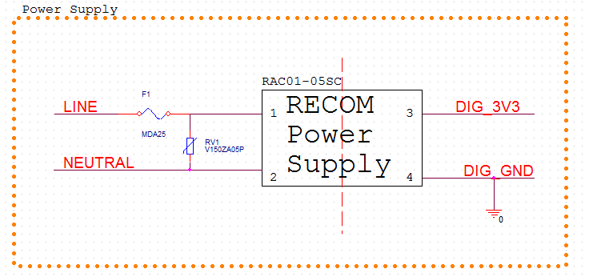

Figure . Power Supply Schematic

#### Generation 2 – Power Supply Implementation

Figure 7 shows an initial design for the second generation DC power supply.

Design Notes for Capacitively Coupled Power Supply:

* Based on the necessary DC voltages, and currents needed part values will change. Due to the many design factors still seen as unknowns.
* The basic operation of the circuit is as follows.
  + During positive half-cycles of the 120 VRMS sine wave, D1 is forward biased thus charging up the C3 capacitor. The rate of charging of the C3 capacitor is controlled by the C1, R1 impedance. C1 is used to limit the power dissipated, and R1 is used to handle in-rush currents when power is initially applied.
  + During negative half-cycles of the 120 VRMS sine wave, D2 is forward biased to maintain AC current through C1.
  + The R2 resistor was selected to bias the Q1 transistor. The D5 zener diode is used to keep the base of the Q1 transistor at a given voltage. This allows the Q1 transistor to act as a voltage regulator, with an output voltage given by Vz(D5) – 0.7V or approximately 5 VDC.

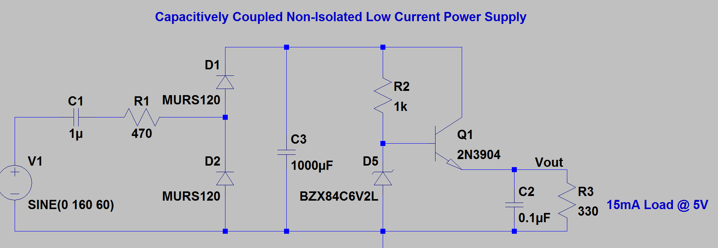

Figure . Capacitively Coupled Power Supply

### Load Switch

The load switch must be capable of switching the power across the load, while preferably having its control circuit electrically isolated from the AC line.

A schematic showing the implementation of the load switch is in Figure 9.

Design Notes for load switch:

* MOC3063M refers to an optically coupled TRIAC driver with zero crossing circuitry. The functional schematic for the MOC3063M, per the data sheet, is shown in Figure 8. The MOC3063 is an optical TRIAC driver, thus allowing an isolated source to drive a TRIAC. The M0C3063 also has zero crossing circuitry thus eliminating the need for timing the TRIAC fire pulse with the AC line zero cross. To turn the TRIAC ON, the LED between 1 and 2 must be illuminated (current flowing thru device). To turn the TRIAC OFF, the LED between pins 1 and two must be non-illuminated (no current flow thru device).
* Due to the built in zero crossing circuit the MOC3063M TRIAC driver cannot be used for implementing phase control switching of the TRIAC. There are pin compatible opto TRIAC drivers without internal zero crossing circuitry which can be used if it is later determined that the design should be capable of lamp dimming.

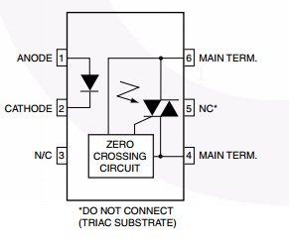

Figure . MOC3063 Functional Diagram

* The operation of the load switch is as follows:
  + OFF – When off functionality is required the processor will drive its output low. This will turn off the Q2 transistor thus providing no current flow thru the light emitting diode.
  + ON – When on functionality is required the processor will drive its output high. This will cause a base current turning on the Q2 transistor and providing a current to flow illuminating the diode of the MOC3063 part.
* R5 is provided to limit the current when the load switch is on to (3.3V – Vled) / 510 ohms.
* R3 is chosen to limit the Q2 base current to (3.3V-0.7V)/10 kohms.
* R4 is chosen such that the transistor will be connected to ground when the processor output is open thus insuring the load switch will remain off when not driven by the processor, which is seen as good practice as this guarantees the device will not falsely turn on.
* An RC snubber (R1 and C1) is designed to limit the rate of change in voltage with respect to time thus preventing the TRIAC from erroneously turning on.
* The TRIAC Q1 is used to switch the AC power across the load. When the gate is ON the TRIAC acts as a short circuit, whereas when the gate is OFF the TRIAC acts as an open circuit once any existing load current drops below the holding current. The TRIAC is bidirectional and therefore will conduct current for both the positive and negative cycles. The TRIAC was selected to safely switch 20 amp continuous loads in 120 VRMS circuits. It will need to be mounted on a heat sink to run high current loads continuously.
* R2 is used to connect the gate of the TRIAC to the main terminal when the gate is not being driven to zero thus preventing the TRIAC from false latching on.

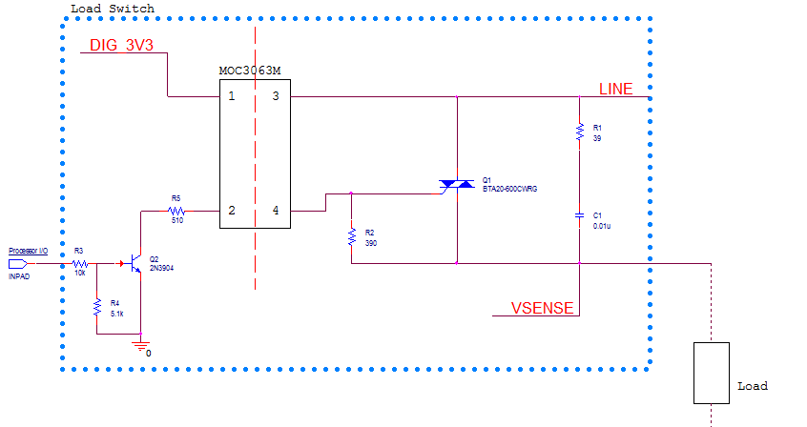

Figure . Load Switch Schematic

### Power Sensing

Power sensing has been broken into two sub-modules of current and voltage sensing. Through the acquisition of the voltage and current characteristics important power parameters can be tracked. Current sensing circuitry which generates an analog voltage proportional to the sensed current, and voltage sensing circuitry which generates a voltage proportional to the sensed voltage will be fed into ADC converters of the chosen controller which will then use this information to determine the current and voltage waveforms in real-time.

#### Current Sensing

The designed current sensing circuit schematic is shown in Figure 12.

Design Notes for Current Sensing:

* The ACS722 refers to a Hall effect current IC manufactured by Allegro. A block diagram showing the chip functionality, from the data sheet, is shown in Figure 10.

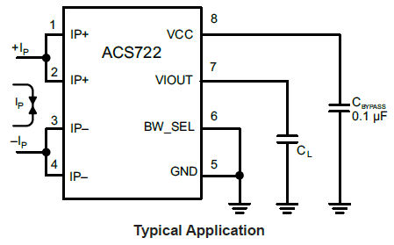

Figure . Hall Current Sensor IC Typical Usage per Datasheet

* The ACS722 will measure a bidirectional current, which is run through pins 1, 2 and 3, 4. An output voltage will be generated on pin 7 which be proportional linearly to the sensed current with an offset of Vcc / 2. Figure 11 shows the expected voltage outputs for various current levels.

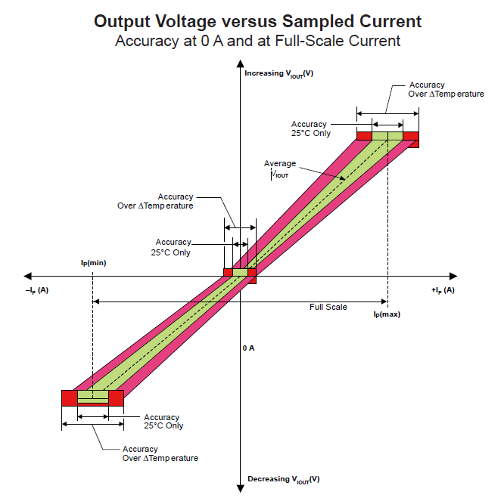

Figure . Input Current vs Output Voltage Characteristics of Current Sense Chip

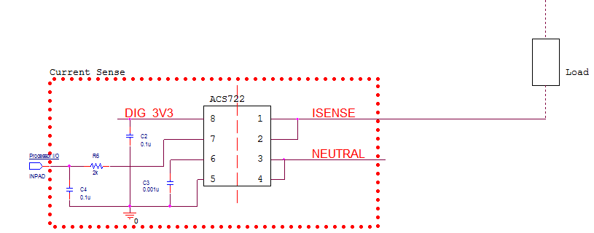

Figure . Current Sense Circuit Schematic

* C2 is a decoupling capacitor recommended by the data sheet application note.
* C3 is a filter capacitor recommended by the data sheet application note.
* C4 is an optional filter capacitor which may be needed depending on the signal integrity of the output voltage.
* R6 is a current limiting resistor, to protect the processor from sinking too much current.

#### Voltage sensing

The designed voltage sense circuit schematic is shown in Figure 14.

Design notes for Voltage sense:

* The ACPL-C87A refers to an integrated circuit which provides an optically isolated amplifier designed specifically for voltage sensing. It has a 2V input range and a high input impedance thus minimizing its loading effects. A differential output voltage that is proportional to the input voltage is created on the output side of the optical isolation barrier. The part uses sigma-delta modulation technology to transmit the signal information digitally across the isolation boundary. The functional block diagram for this part can be seen in Figure 13.

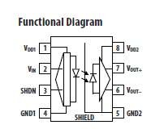

Figure . ACPL-C87A Functional Diagram

* The ACPL-C87A provides an isolated amplifier allowing the controller to sample the line voltage. The ACPL-C87A requires two isolated supply voltages: one for the digital side, and one for the line side. The digital voltage DIG_3V3 can be provided by the main power supply. The digital generated voltage DIG_3V3 CANNOT supply the line voltage, as this would break the isolation barrier defeating the purpose of the chip. Therefore to provide a 5V reference to Neutral, a simple capacitively coupled power supply is generated which is capable of sourcing the 15mA required by the isolated amplifier input side circuitry.
* The capacitively coupled power supply is shown below the green box of the Voltage Sense block. It takes the line (120 VRMS) with respect to Neutral and produces a 5V reference capable of providing 15 mA. The functionality of this capacitively coupled supply is the same as the capacitively coupled supply discussed in the generation 2 power supply design section.
* The voltage sense circuit senses the line voltage, feeds a part of this voltage into the isolation amplifier, which then allows the processor to determine the sensed voltage.
* R7, R8, R9 and R10 function as a voltage divider such that the 120 VRMS line voltage is scaled down to 2V to be fed into the isolation amplifier. The maximum line voltage was assumed to be 160 VRMS, so this value was to correspond to 2V as seen by the isolation amplifier input. The chosen resistor values result in the following input voltage at 160 VRMS.
* The series connection of R7, R8, and R9 is the part of the voltage divider responsible for dropping most of the line voltage. Therefore a large value of 300k ohms was chosen to minimize power dissipation. (V2/R). This resistor was also split up into three resistors, which is standard practice in this application as it allows for the power dissipation to be divided among three different resistors instead of having all of the power dissipated across one resistor. In this configuration, the maximum possible power dissipation of each R7, R8 and R9 is 27.738 mW.

* 158 V is the voltage differential across the total series combination of R7, R8 and R9. Since all resistors are of equal value the voltage will be evenly split across each resistor.
* 100kohms is the chosen value of the resistors.
* C5 is a filter capacitor for the amplifier input voltage.
* C6 and C7 are decoupling capacitors as specified by the datasheet.
* The amplifier with resistors R12, R11, R13, and R16 is a balanced differential amplifier capable of performing signal conditioning and gain adjustment, which may or may not be needed.

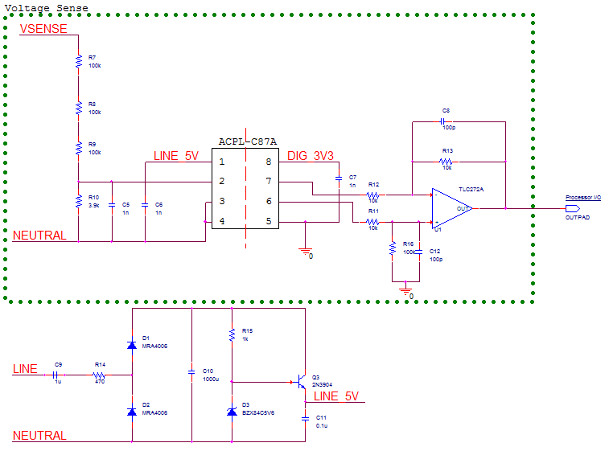

Figure . Voltage Sense Schematic

### Surge Protection

The selected design consisted of a slow blow fuse and a MOV as shown in Figure 6. Both the fuse and the MOV will have no effect on the circuit during normal operation. In the event of a surge voltage transient, the MOV will dissipate any excess energy thus keeping the line voltage from exceeding 160V. In the event of the MOV failing as a short circuit the fuse will burn out thus breaking the path of current flow and protecting all circuit components.

### Controller

The controller to be used is the MSP430 and is responsible for the tasks shown in Figure 15. Rectangular blocks within the controller correspond to software blocks, which will be developed, and oval block correspond to external hardware circuitry that the controller will interface with. The tasks, which are shown in Figure 15, are described as follows:

* Programming Interface – Provide an interface which can be used to program the MSP430 such that iterative development can take place
* LED Driver – Status LEDs providing user feedback are desired. The LED driver is responsible for determining state of LEDs and turning them OFF or ON depending on desired functionality.
* Current Monitoring Driver – The current monitoring driver is responsible for handling the samples from the current sense hardware. The current sense hardware shall also decipher the results of the current sense hardware and produce a result usable for power calculations.
* PLC Controller- Provide an interface to communicate off chip via the power line communication hardware. Tasks will include transmitting and receiving data between remote and main units.
* Power Calculations – Provide power calculations based on current and voltage measurements. While exact calculations to perform are still unknown at this point likely characteristics include: power factor, instantaneous real and apparent power dissipated, average power dissipated, kW/hours etc.
* Current Voltage Phase Calculations: Current and voltage phase calculations will be necessary to determine the power factor.
* Load Switch Driver – Provides control of the load switch hardware, by commanding the load to the ON or OFF condition. This block will also be responsible for shutting the load switch off in the event of an over current/voltage fault.
* Voltage Monitoring Driver- The voltage-monitoring driver is responsible for handling the samples from the voltage sense hardware. The voltage sense hardware shall also decipher the results of the voltage sense hardware and produce a result usable for power calculations.



Figure . Controller Diagram

## Power Line Communication

Because of concerns about achieving the minimum data rate, it was determined that power would be measured and transmitted for single gangs (2 outlets – not for each single outlet). This makes it so the system could support roughly twice the number of outlets for a given data rate. There are many formats and contents of data that could be transmitted to convey power usage. The two primary choices for power usage transmission are either transmit only power or transmit three components – as current, voltage, and power factor – that allow for calculation of power. While the three component transmission would utilize more data, it would allow for users to view data relating to voltage levels, which is a unique feature that could help users identify issues with wiring and connections. For transmission of three components, many of the components could be reduced to save on the number of transmitted bits. Voltage could be transmitted as a difference from 100 V (or a similar number) utilizing a 5-bit number to range between 100 & 131 volts. Current could be specified with an accuracy of about 16.5 mA using a 10-bit resolution, and the power factor ranges from 1 to -1, which could be specified in 8 bits, which would give an accuracy of 0.008.

All of these considerations impact the rough estimate shown in Equation 1, and create two different equations based on the chosen power transmission scheme. Another factor is that if the address bits of the packet header are not easily accessible, or if they change dynamically, then each transmission will be required to transmit an ID. The number of ID bits will be dependent on the number of supported outlet modules (M), which have two outlets per gang. As their data will be combined, this is not a concern for the sending of usage data, but an additional ID bit will be required to send commands to individual outlets, and not the entire module. The number of ID bits for transmissions from gangs will be the ceiling function of log­­­2(M), in order to provide just enough bits for unique identifiers. Equation 2 shows the estimation equation for transmissions sending only power data, while Equation 3 shows the estimation equation for transmissions sending power factor, voltage, and current data. Please note that this assumes data are transmitted in a single packet, and requires modification to estimate multi-packet transmissions. The square brackets surrounding the ID section indicate that it may or may not be necessary depending on the chosen chip.

**(2)**

**(3)**

Respective minimum data requirements were then calculated using Equations 2 and 3, along with the assumptions of 0 packet headers with only ID (true minimum packet header size in reality), a single component power indicated with 11 bits, a voltage indicated with 5 bits, a current with 10 bits, and a power factor resolution with 8 bits. Additionally, M (modules) was chosen as 100, with a transmission frequency of once every 15 seconds. Utilizing these values, the minimum required bandwidth for single component power was estimated at 120 bps, with a 3-component power requirement of 200 bps.

To allow for near real-time viewing of data, it would be practical to have the ability for the main module to request a non-default transmit rate. For example, all modules could transmit once every 15 seconds, but the main module could request a certain gang (or group of gangs) send at a rate of once per second, for real-time viewing. Assuming the default frequency is FD, and the real-time viewing frequency is FR, and the maximum number of items in a real-time viewing group is MR, then Equations 2 and 3 can be modified as shown in Equations 4 and 5, respectively.

**(4)**

**(5)**

Assuming the prior assumptions, and that the biggest real-time group with a frequency of one transmission per second is 5 modules, the minimum bandwidth for a perfect transmission, no collision model would be 204 bps for a single power component transmission, or 340 bps for a 3 component power transmission model.

For the chosen CY8CPLC10 chip, whose packet size is 56 bits, the data rate provided the previous assumptions would need to be at least 760 bps for single component power, and 896 for triple component power, both of which are less than the provided data rate of 2400 bps. Further, if the data rate is slightly too high during implementation, the number of outlets may be modified, since a typical home does not have 200 outlets, which will drastically effect the data rate.

The pinout of the CY8CPLC10 28-pin SSOP is shown in Figure 16.

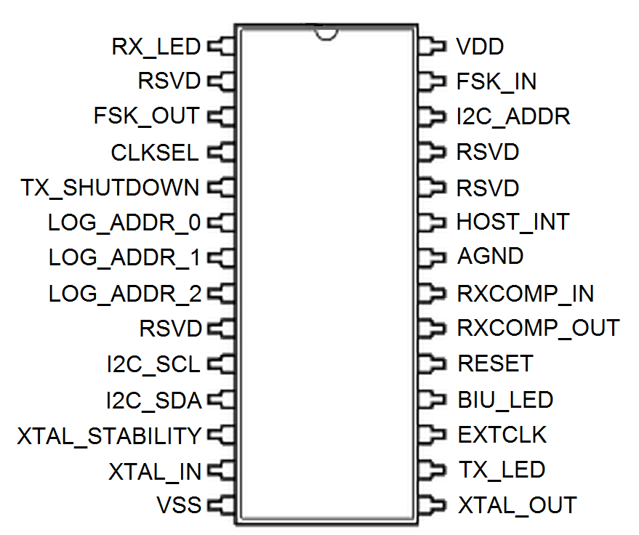

Figure . CY8CPLC10 Pinout

Because PLC is a mature technology, the operation of the PLC chip is relatively straightforward. The chip is connected to the main microcontroller using I2C to communicate to the PLC chip. Each module will be equipped with the chosen PLC chip, which will simply act as a black box system to pass information from the outlet modules to the main module, and vice versa. A simplified view of the system is shown below, in Figure 17.

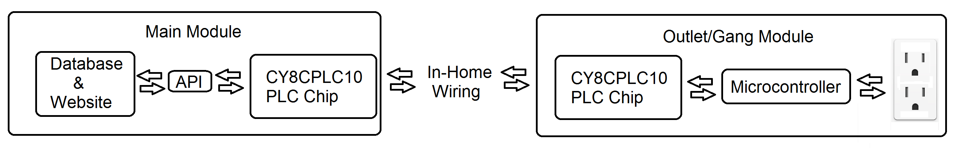

Figure . PLC System Overview

Figure 17 shows that each module is equipped with one of the selected PLC chips, and uses it as an interface with other modules. In the case of the Main Module, it interacts with each of the outlet modules via the PLC chip. Each outlet module need directly interact only with the main module however. Each outlet module consists of a “gang” (2 outlets) equipped with a single microcontroller, a single PLC chip, coupling, control, and measurement hardware. At the interval specified by the Main Module, the Outlet modules’ microcontroller will average the power consumption and send the data to the Main Module via the PLC chip. The transmission frequency will be variable, so that the Main Module may request real-time data from individual modules. The Main module will constantly receive data from remote modules and update its database, but will also be able to issue commands to turn the remote outlets on and off. Figure 18 summarizes the interactions that are necessary with the PLC connection.

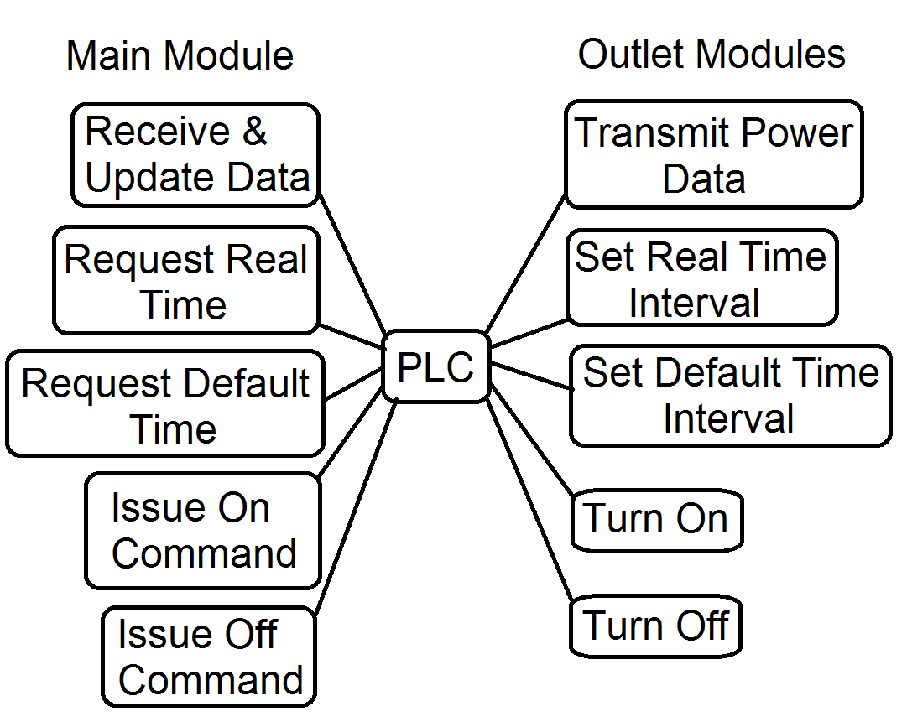

Figure . Commands & Updates Facilitated by PLC

As previously mentioned in equations 4 and 5, there are multiple formats that the power data may be transmitted in. If it is decided that the chosen assumptions are valid, or close to accurate, then the margins are close enough that it is probably worthwhile to select the 3 components power (Equation 5) for transmission, as it is a more data rich measurement, and can provide for unique features. However, this data will come preformatted by the microcontroller, and is not a concern of the PLC chip other than the data rates, which have already been considered in selection of the chip.

Receiving and transmitting data on the power line requires that the PLC be coupled with the mains wiring. There are two main coupling types under consideration, which will be chosen based on the other choices in the design. Utilization of transformers will isolate the PLC while coupling it with the main wiring, and will be utilized if the microcontroller is isolated as well. If the microcontroller is not isolated, then the PLC will be coupled capacitively. Such couplings are already widely available in application notes for many of the discussed chips. Utilization of transformers throughout the design would isolate the design at the expense of space, but would help to protect the system from damage. However, if the microcontroller’s supply is not isolated, then the space used at the transformer coupling of the PLC chip would be wasted as it would not be isolated anyways, which is why the selection is dependent on the microcontroller’s coupling. For the Main Module, it is expected to be coupled with a transformer, as the data center should definitely be isolated and protected from the power line.

## Web Application

The application will be constructed using the standard web application layer design where each part of the application is separated into layers that interact with each other. This reduces coupling within the application and allows for easy maintainability and upgradability. Figure 19 shows an example of this layering from Microsoft.

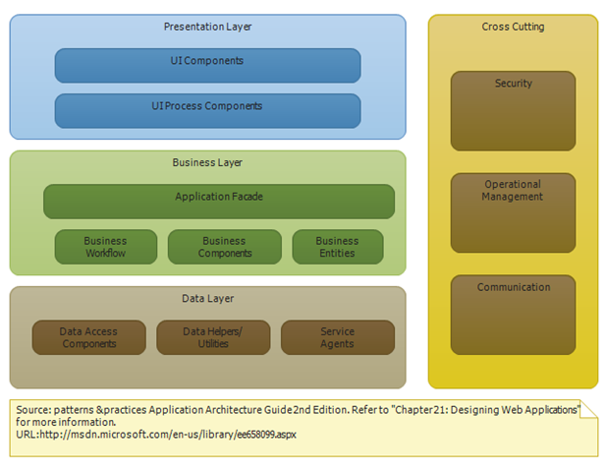

Figure . Web Application Layering

Figure 19 shows that there are three main layers and other components that interact with all of the layers. This is the typical design of a web application that is used by most in industry. The presentation layer (or UI layer) is where the user interface is implemented. This layer will include everything the user will see and interact with. So all the power consumption charts, the naming and grouping interface, and the scheduling or control interface will be implemented in this layer. The business layer (or service layer) is where the UI will communicate to get information or perform tasks the user requested. In this layer the user’s requests from the UI layer will be processed and requests will be made to the data layer if needed. This layer also handles anything that needs to be displayed from the data layer. The service layer will process this information and pass it up to the UI layer. In the data layer is where the actual requests, and queries to the database are performed. There is usually a request from the service layer that requires data to be fetched or modified. The data layer handles parsing these requests into queries, running the queries against the database, and returning the results. The right-hand box shows some components that integrate with each layer such as security and communication. This design makes the application as loosely coupled as possible, which is beneficial. A loosely coupled design is easier to maintain, upgrade, and allows for the development work to be divided easily. This design will also ensure the user interface is as simple as it can be because the UI will not be coupled to the data in any way.

The user interface is a crucial part of the design of the web application. The interface will be the sole interaction between the user and the system and therefore must be simple and intuitive. Figures 20-23 show a mock-up of the interface.

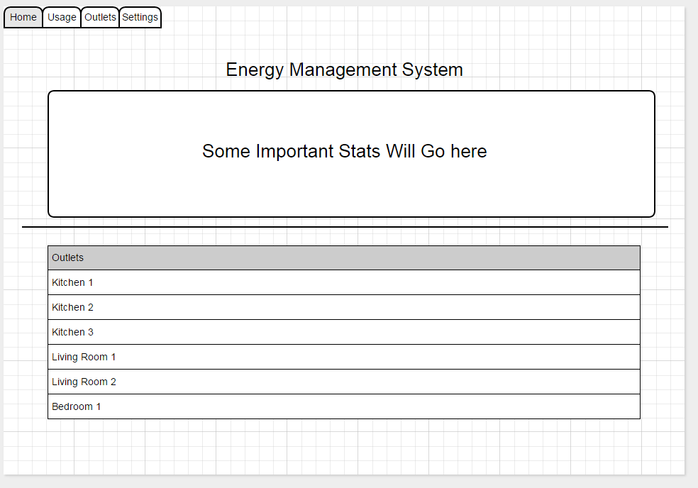

Figure . Home Tab of UI

Figure 20 shows the home tab of the application. This will be the screen that the user will see after they login to the application. Here, there will be some sort of title on the top and some basic statistics that the user will want to see quickly. These statistics can include current power consumption, current energy use this month, current estimated cost this month, or other related statistics. The bottom half of this screen will be a list of all the outlet modules (or groups). From here the user will be able to change name of the modules and toggle the state of the modules (on or off) independently of the schedule.

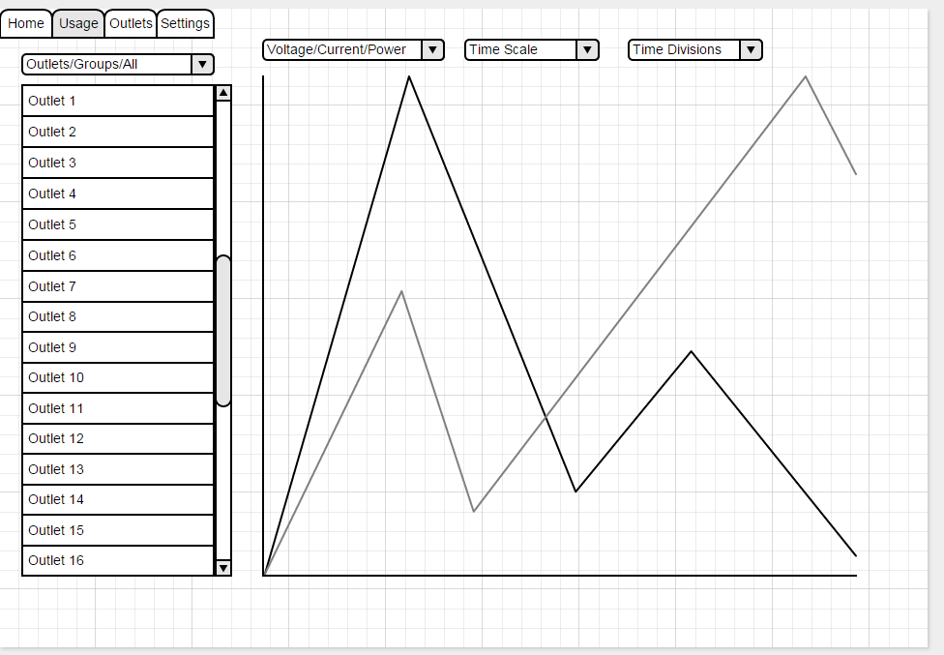

Figure . Usage Tab of UI

The next tab will be the usage tab (shown in Figure 21). This is the tab where the user will be able to view all the charts for their energy usage. Figure 21 is a general overview of what the screen could look like. The user will have some way to select the outlet or group that they will want to view. There will then be one or more graphs where the user can select what they want to view (voltage, current, power, kWh, cost), the time scale of the graph (real-time, day, week, month, year, etc.), and the time divisions of the graph that will be dependent on the time scale selected. There may be multiple graphs on this screen that can display multiple data at once or there is a possibility of displaying multiple lines on a single graph. This tab will be the most important tab and require the most development effort. The need to display so much information in so many different ways will cause this tab to require an extensive coding effort.

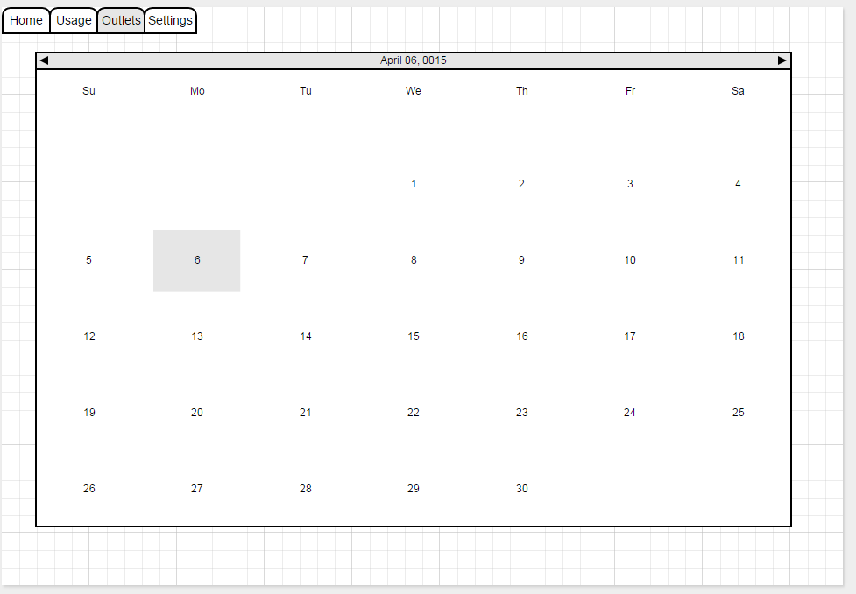

Figure . Outlet/Scheduling Tab of UI

The next tab (shown in Figure 22) will be the location where the user can setup the schedule for various modules and groups. The exact implementation of this functionality is not known yet, but the vision is to have a calendar interface where the user can add events on any date and time, edit events, add repeated events, and other related tasks. The hope is to have an interface similar to that of Google Calendar or a similar scheduling application.

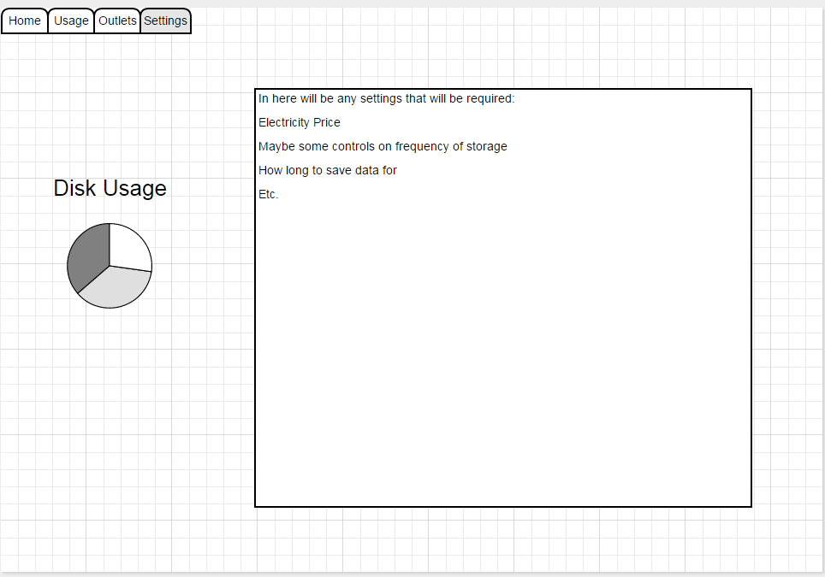

Figure . Settings Tab of UI

The final tab (shown in Figure 23) will be the settings tab. This is where the user will be able to configure various aspects of the application. There will also be a way to show the user how much disk space is remaining on their unit so they will know if their unit is close to running out of space. The exact settings are not known at this time, but there will probably be settings to configure the cost of electricity for the user, the frequency at which the application stores data, and other server-related tasks.

## Data Storage

### Database Model

The MySQL database management system will store the various components of the system in separate tables. Figure 24, below, shows the overall components of the database. The Users table will hold any relevant usernames, such as the homeowner or business, as well as an administrative account.

The Outlet Module table will contain all of the outlet modules, which are the major components of the Energy Management System. The outlet ID is primarily used for querying the outlets, and will remain internal to the database and web application. The user will identify the outlets by name, which can be customized. The Outlet Module’s address will be stored as a 64-bit binary value, and will be used to communicate with the actual module. The frequency and real-time columns are for the update frequency and real-time flag, respectively. If the user requests a real-time update of an outlet, then the real-time flag is set, and the update interval (in seconds) is set to 1.

The Outlet Reading table will hold all of the outlet readings that are sent to the main unit, from the individual outlet modules. The reading ID is an internal primary key for the table, and can be used to identify the reading within the database. The table will store the outlet ID, voltage reading, current reading, and power factor reading from the associated outlet module. A timestamp is inserted at the time the reading is created, which will allow the user to view a range of readings through the web application. The real-time bit is associated with the outlet module’s real-time bit.

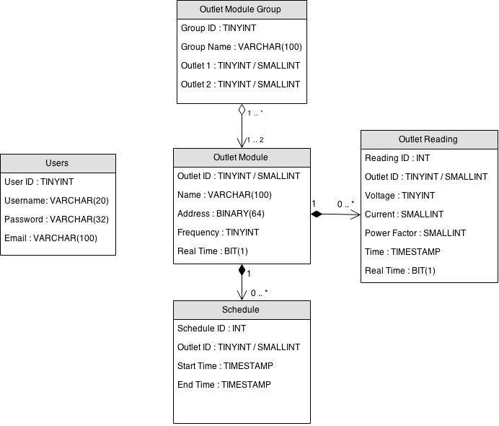

Figure . Database UML Diagram

The Schedule table will hold any user-defined schedules for individual outlets. Currently, the table allows for choosing only an outlet module, a start date/time, and an end date/time. Depending on the implementation of scheduling, another column may be necessary to determine whether or not the outlet module should be turned on or off.

### Data Compression

It is unlikely that users will need to see the 15-second resolution of outlet readings after a period of time. Because of this, the data can be "compressed," by averaging a certain number of readings into one. To accomplish this, every day, the main unit will query all of the readings that are 30 to 31 days old, and then average four 15-second readings into one minute reading. The voltage, current, and power factor are averaged and stored into one of the original rows. The other rows associated with the averaging are then deleted.

To take this further, the compression can be applied more and more, eventually generalizing readings from a resolution of 15 seconds to 1 hour, to 1 day, or even broader if necessary. Currently, it is unknown if the compression will go beyond averaging 15-second readings into 1-minute readings.

Real-time readings are deleted after the user's session ends. Because the user is interested in temporarily seeing the real-time power used by an outlet module, the readings can be discarded after the user ends the session. Every 15th reading will have its real-time flag set to “0,” indicating that it is a normal reading and should not be immediately deleted.

## Engineering Standards

There are many engineering standards associated with the design of the EMS project. First and foremost, the system interfaces with the 120 VRMS, 60-Hz AC power line to provide the main functionality of the system. The I2C standard will be utilized to interface between the controllers and the power line communication chips. The modules must meet the form factor of a standard household electrical outlet box. For microcontroller software development, the Texas Instruments Code Composer Studio will be used. Eclipse will be used for development of the Raspberry Pi 2 web interface. The SQL standard will be used for database development.

## Multidisciplinary Aspects

This project involves aspects pertaining to computer, electrical, mechanical, and software engineering. Table 12 provides a brief description of the tasks involved for the various disciplines.

Table . Multi-Disciplinary Aspects

|  |  |
| --- | --- |
| **Multi-Disciplinary Aspects** | **Relevance to Project** |
| Computer Engineering | Interface between hardware components and processor. Development of firmware to drive device hardware. |
| Electrical Engineering | Circuit design, PCB layout |
| Mechanical Engineering | Design of enclosure for various modules |
| Software Engineering | Development of a web-app to display data and remotely configure outlets |

## Background

Completion of the Energy Management System will require the utilization of a multitude of skills. Some of the most important skills associated with the project include PCB layout, hardware and software interfacing, circuit design, web application design, database construction, communication, and signal integrity analysis. Core computer and electrical engineering classes taken by group members, such as Software Engineering, Interface and Digital Electronics, Circuits I and II, Electronics I and II, Linear Systems, Communications Systems, and Data Communication provide the necessary background in these skills. Outside of these classes, personal experience in Wireless Networks has been extremely valuable for communication design.

Donald MacIntyre has had experience with PCB design, layout, signal integrity, and high voltage power design from multiple co-op blocks at Moog Inc. Andrew Cope has had experience with database construction in personal projects, as well as for professional websites. Jacob Lauzon has had considerable experience designing Java web applications through The Echo Group.

## Outside Contributors

Dr. Andres Kwasinski offered direction and advice in regards to the utilization of power line communication, and will act as a primary contact with communication concerns.

# Constraints and Considerations

## Extensibility

The current focus of the project is for residential buildings and possibly small businesses; however, the design could be extended to large businesses and large buildings. This would only include an addition of outlet modules and, depending on the size of the install, possibly higher performance PLC chips. The main concern with larger systems would be the fact that large buildings use three-phase power directly. Some adaptations would need to be made to measure the three different phases. In addition to larger systems, smaller systems could also be created. For instance, single, network connected outlet modules that can be purchased separately.

## Manufacturability

The system will be scalable and ultimately mass-producible. Both the outlet modules and the main unit will be assembled on a Printed Circuit Board (PCB) that can be easily mass-produced. As the component parts will be bulk-ordered, the overall cost of the system per unit will be reduced.

## Reliability

The system will need to be very reliable, as it will need to be powered on and measuring data 24/7. The system will also need to be able to recover from a power outage without human interaction. The design allows for a reliable system because the user will not have to manually restart the system components.

Before attempting to mass-produce the Energy Management System, Highly Accelerated Life Testing (HALT) will be performed to attempt to quantify the Mean Time Between Failure (MTBF) of the Energy Management System. Tools such as Sherlock, which is a software tool providing automated design analysis, could be used to model failure rates and determine the complete product life curve. Based on the results of Sherlock’s Automated Design Analysis tools, MTBF issues can be addressed early in the design cycle. Due to the high cost of the Sherlock software, it is not feasible to perform this analysis as part of this project. An electrical stress analysis can be performed using standard circuit analysis techniques to verify that components have sufficient deratings.

## Health and Safety Issues

The system will need to have surge protection, to prevent any connected devices or outlet modules from being damaged. The system components will also need to be Underwriters Laboratory (UL) recognized, to ensure that potential risks are limited and safety standards are met. In order to commercially sell the Energy Management System, it will be necessary in the United States to obtain approval from UL and other safety agencies in foreign countries which could be expensive.

## Intellectual Property

The system’s web application software will be proprietary.

With the smart grid industry on the rise there are many provided resources such as example code and application notes. For example, companies such as Texas Instruments, in an effort to encourage design engineers to choose their products, make available at no cost application notes and sample code. Therefore, the programming effort for this design will most likely heavily leverage available code. Also, there are many open source projects that have been developed in the past, which can be referenced. Additionally, energy-metering algorithms are provided by multiple vendors. These public domain algorithms will serve as a basis for the embedded development.

## Environmental

The EMS will monitor and control outlet power consumption, allowing users to reduce their power consumption. Lowering power consumption is an integral part of sustainability. Similarly, the outlet modules and main module will be designed such that they consume minimal amounts of power. It is important the system does not utilize more power than it can save the user. While the project would still be useful for automation, low power consumption is required for high efficiency.

Saving power is a significant feature, since society’s heavy reliance on fossil fuels increasingly makes global warming a concern. Unsustainable power consumption must be curbed to halt global warming.

## Sustainability

Minimizing power consumption promotes energy conservation which results in environmental sustainability. The EMS provides a green technology via its monitoring and control capabilities intended to provide a tool for consumers to consume power as efficiently as possible. To the maximum extent possible the EMS hardware will be designed and fabricated with environmentally friendly materials, such as lead free solders.

# Cost Estimates

Table 13 and 14 show the cost estimates of each part of the outlet modules and main unit respectively. Part selection was limited to components that were in stock at DigiKey a well-known national electronics distributor. Table 13 and 14 also provide hyperlinks to component datasheets by selecting the part number. The final column in the tables indicate in what functional block of the design the particular component is used. The cost per unit listed is the low quantity DigiKey cost. It is also anticipated that a printed circuit board will be designed and fabricated using an online prototype shop such as Sunstone. The cost for fabricating a couple of blank PCBs is estimated to be $250. In addition, Texas Instruments offers evaluation boards of their MSP430 microcontrollers for energy meter applications. An EVM430-F6779 is available from DigiKey for $310. Although expensive, this or a similar unit will be investigated as a potential platform for power management firmware development. A full cost estimate is shown in Table 15 for 3 outlet modules and 1 main unit. Full production level costs are anticipated to be 25% to 35% of the low quantity analysis performed here.

Table . Outlet Module Cost

|  |  |  |  |  |  |  |  |
| --- | --- | --- | --- | --- | --- | --- | --- |
| **Part Number** | **Description** | **Vendor** | **Cost**  **per Unit** | **Qty** | **Ext Cost** | **Lead Time** | **Functional Block** |
| [RAC01-05SC](http://www.recom-power.com/pdf/Powerline-AC-DC/RAC01_02-SC.pdf) | AC/DC switching power supply | Recom | $ 12.34 | 1 | $ 12.34 | stock | Power Supply |
| [V150ZA05P](http://www.littelfuse.com/~/media/electronics/datasheets/varistors/littelfuse_varistor_za_datasheet.pdf.pdf) | Varistor | Littelfuse | $ 0.56 | 1 | $ 0.56 | stock |
| [MOC3063M](http://www.fairchildsemi.com/datasheets/MO/MOC3061M.pdf) | Optoisolator | Fairchild Semi | $ 0.95 | 1 | $ 0.95 | stock | Load Switch |
| [MMBT3904](http://www.fairchildsemi.com/datasheets/MM/MMBT3904.pdf) | NPN Transistor | Fairchild Semi | $ 0.15 | 1 | $ 0.15 | stock |
| [BTA20-600CWRG](http://www.st.com/web/en/resource/technical/document/datasheet/CD00004893.pdf) | TRIAC | STMicroelectronics | $ 1.97 | 1 | $ 1.97 | stock |
| [ACS722](http://www.allegromicro.com/~/media/Files/Datasheets/ACS722-Datasheet.ashx) | Hall Effect Current IC | Allegro | $ 5.27 | 1 | $ 5.27 | stock | Current Sense |
| [ACPL-C87A](http://www.avagotech.com/docs/AV02-3563EN) | Isolated Voltage Sense | Avago | $ 6.42 | 1 | $ 6.42 | stock | Voltage Sense |
| [TLC272A](http://www.ti.com/lit/ds/symlink/tlc272a.pdf) | dual op-amp | TI | $ 1.35 | 1 | $ 1.35 | stock |
| [MMBT3904](http://www.fairchildsemi.com/datasheets/MM/MMBT3904.pdf) | NPN Transistor | Fairchild Semi | $ 0.15 | 1 | $ 0.15 | stock |
| [BZX84C5V6](http://www.fairchildsemi.com/datasheets/BZ/BZX84C10.pdf) | 5.6 Zener Diode | Fairchild Semi | $ 0.19 | 1 | $ 0.19 | stock |
| [MRA4006](http://www.onsemi.com/pub_link/Collateral/MRA4003T3-D.PDF) | 1A, 800V diode | On semi | $ 0.31 | 2 | $ 0.62 | stock |
| [MSP430F672](http://www.ti.com/lit/ds/symlink/msp430f6720.pdf) | Embedded Microcontroller | TI | $ 7.31 | 1 | $ 7.31 | stock | Controller |
| [CY8CPLC10](http://www.cypress.com/?docID=45757) | PLC Chip | Cypress | $ 9.04 | 1 | $ 9.04 | stock | Power Line Communication |
| **Cost** | | | | | $ 46.32 |  |  |

Table . Main Unit Cost

|  |  |  |  |  |  |  |  |
| --- | --- | --- | --- | --- | --- | --- | --- |
| **Part Number** | **Description** | **Vendor** | **Cost**  **per Unit** | **Qty** | **Ext Cost** | **Lead Time** | **Functional Block** |
| [CY8CPLC10](http://www.cypress.com/?docID=45757) | PLC Chip | Cypress | $ 9.04 | 1 | $ 9.04 | stock | Power Line Communication |
| [Pi 2](http://www.google.com) | Raspberry Pi 2 | Amazon | $ 35.00 | 1 | $ 35.00 | stock | Main Unit |
| [SDSDQUAN-032G-G4A](http://www.amazon.com/SanDisk-Memory-Adapter--SDSDQUAN-032G-G4A-Version/dp/B00M55C0NS/ref=sr_1_1?s=electronics&ie=UTF8&qid=1430167833&sr=1-1&keywords=32+gb+micro+sd+card) | 32 GB MicroSD Card | Amazon | $ 16.19 | 1 | $ 16.19 | stock | Main Unit |
| [EW-7811Un](http://www.amazon.com/Edimax-EW-7811Un-150Mbps-Raspberry-Supports/dp/B003MTTJOY/ref=sr_1_2?s=electronics&ie=UTF8&qid=1430166212&sr=1-2&keywords=edimax+usb+adapter) | USB Wireless Adapter | Amazon | $ 9.23 | 1 | $ 9.23 | stock | Main Unit |
| **Cost** | | | | | $ 69.46 |  |  |

Table . Complete Cost of Selected Number of Modules

|  |  |  |
| --- | --- | --- |
| Module Type | Number of Modules | Cumulative Cost of Module Type |
| Main Module | 1 | $69.46 |
| Outlet Module | 3 | $138.96 |
| Full Cost |  | $208.42 |

# Testing Strategy

## Testing Schedule

The initial testing schedule is provided in Table 16. Adjustments to the schedule may be made depending upon other aspects of the project. Unit testing will be done first, to ensure that individual components of the Energy Management System are working correctly. The integration testing follows the unit testing, and is responsible for ensuring that the components work together with one another. Finally, acceptance testing is performed to ensure the system as a whole is working correctly to meet the engineering and marketing requirements.

Table . Preliminary Testing Schedule

|  |  |
| --- | --- |
| Unit Testing | June 2015 |
| Integration Testing | September - October 2015 |
| Acceptance Testing | October - November 2015 |

## Unit Tests

Unit tests verify that individual components are operating as expected. Unit tests are critical to properly debugging a project, as they significantly reduce the scope of variables to be tested. Unit tests validate individual components, ensuring that higher level tests will not fail due to unexpected operation of the subcomponents. The complete unit tests for this project are shown in section 12.1 of Appendix B.

## Integration Tests

Once the Unit tests have been passed, it is critical that the boundary between the subsystems are thoroughly tested. This boundary is known as the interface between components, and is the primary location for errors when endeavoring to utilize integration tests. In addition, it is only upon integration that some components can be tested, as they lack a usable interface for reasonable tests. Thus the complete Integration tests for the EMS is shown in section 12.2 of Appendix B.

## Acceptance Tests

Acceptance tests are the tests conducted to verify that the requirements of a project have been met. Acceptance tests validate the product, and verify that it works as expected upon completion. As such, the acceptance tests of the EMS are closely coupled to the engineering requirements. Passing all acceptance tests will guarantee that all marketing and engineering requirements have been satisfied. In order to release a finished product fulfilling the engineering specifications, the project must pass the following tests. The complete acceptance tests for the EMS are shown in section 12.3 of Appendix B.

## Test Coverage Matrix

The test coverage matrix verifies that all engineering requirements are fully tested. The requirement number corresponds to requirements listed in section 3, whereas the test number corresponds to the tests listed in Appendix B. The test coverage matrix is shown in section 12.4 of Appendix B.

# Risks

## System Electronics

### Power Supply

At this time the load on the power supply is not completely known.

### Controller

The remaining uncertainties for the controller are the requirements of the power line communication interface, which will be required. Uncertainties include number of I/O needed, communication protocols with PLC chip, data transmission speeds, power calculations needed, and the sampling rate. These factors will be strongly impacted by the web UI design and which parameters are chosen to be tracked.

## Web Application

There are few major uncertainties with this design. The first, and biggest, uncertainty is whether or not the Raspberry Pi 2 will be able to handle serving the web application and the database. The Django framework was chosen to reduce memory usage; however the usage is definitely not small. The application’s usage along with the Linux distribution and hosting the database may be too much for the Pi. More extensive testing may need to be done to ensure that the memory usage will not be an issue. In addition to the memory usage, the processing power is a concern. There is some uncertainty as to whether the processor on the Pi will be able to handle all of the requests from the database, the hardware, and the application. If there is too much going on, the performance of the system could be affected.

The next uncertainty is if Django will have enough functionality to implement the desired application. The application seems, simple but there will be lots of dynamic elements and many different charts that will involve very complicated logic. None of the team members have worked with Django before so we are unsure if the functionality we need is really there. If this becomes an issue, a more powerful framework may need to be selected, like Java or more powerful JavaScript libraries. To go along with this uncertainty is also the time concern. This application is going to require an extensive coding effort. While the team is more than capable, the time constraint on the project is a concern because of all of the other components that are required for the Energy Management System. Some elements of the application may have to be dialed back to allow the application to be completed on time.

## Data Storage

### Disk Space

Although MySQL puts some overhead data in the database, it is miniscule against the amount of data needed for the outlet modules and outlet readings. Similarly, the Users, Outlet Module Group, and Schedule tables take up a small amount of disk space. There are two major considerations, when it comes to disk space: the Outlet Module and Outlet Reading tables. Table 17 below shows the estimated size for different numbers of outlet modules.

Table . Outlet Module Table Size for Various Quantities of Outlet Modules

|  |  |  |
| --- | --- | --- |
| **Number of Outlet Modules** | **Maximum Size for Outlet Module Table row:** | **Total Estimated Size** |
| 1 | 112 B | 112 B |
| 10 | 112 B | 1.09 KB |
| 50 | 112 B | 5.47 KB |
| 100 | 112 B | 10.94 KB |
| 300 | 113 B | 33.11 KB |
| 1000 | 113 B | 110.35 KB |
| 10000 | 113 B | 1.08 MB |
| 65535 | 113 B | 7.06 MB |

As seen in the table above, the size for even a large number (65,535) of outlet modules results in a relatively small table size. However, the larger consideration is the Outlet Reading table. Table 18 shows several quantities of outlet modules, as well as two different updating frequencies.

Table . Outlet Reading Table Size for Multiple Outlet Modules

|  |  |  |  |  |  |
| --- | --- | --- | --- | --- | --- |
| **Number of Outlet Modules** | **Update Interval** | **Max Bytes Per Reading** | **Table Size Per Day** | **Table Size Per Year** | **Table Size Per 5 Years** |
| 10 | 1s | 16 Bytes | 13.18 MB | 4.70 GB | 16.99 GB |
| 50 | 1s | 16 Bytes | 65.92 MB | 23.50 GB | 84.98 GB |
| 100 | 1s | 16 Bytes | 131.84 MB | 46.99 GB | 169.96 GB |
| 500 | 1s | 17 Bytes | 700.38 MB | 249.64 GB | 902.91 GB |
| 10 | 15s | 16 Bytes | 0.88 MB | 0.313 GB | 1.133 GB |
| 50 | 15s | 16 Bytes | 4.39 MB | 1.566 GB | 5.665 GB |
| 100 | 15s | 16 Bytes | 8.79 MB | 3.133 GB | 11.331 GB |
| 500 | 15s | 17 Bytes | 46.69 MB | 16.64 GB | 60.194 GB |

The table above shows that, given enough outlet modules, there is a considerable amount of space that needs to be used in order to store the outlet module readings. The table size assumes that no readings are deleted over the lifetime of the product. If the data were not compressed, 32 GB of storage on the main unit would be able to last a maximum of roughly 14 years (with 100 outlets in a home).

### Data Types / Values

Since the Outlet Reading table uses the TIMESTAMP data type, the time is represented in 32 bits. The TIMESTAMP data type represents the number of seconds since 1970. As it is a 32-bit integer, it has a maximum value of 4,294,967,296. This results in the TIMESTAMP maxing out in the year 2038. If the system were to be used past that date, it would be advisable to switch to the DATETIME data type, which is 64 bits long. This would allow for ease of use, at the cost of adding 4 more bytes to the reading row. This is a 25% size increase, but should be mitigated by the data compression.

Similarly, the outlet reading ID is also a 32-bit integer. Assuming the system is not reset during its lifetime, it would take roughly 20.43 years for a 100-outlet building to reach the maximum ID value. From then, older ID values would have to be reused.

# Milestone Chart

Table . Milestone Chart

|  |  |  |
| --- | --- | --- |
| **Task Description** | **Scheduled Completion Date** | **Responsible Team Member** |
| Critical Component Breakout Boards | August 24, 2015 | Ryan, Donald |
| User Interface Implementation | August 24, 2015 | Jacob, Andrew |
| Web App Database Communication | August 24, 2015 | Andrew, Jacob |
| Order Parts | August 26 , 2015 | All |
| Initial PCB Design | August 31, 2015 | Donald |
| Obtain and Verify Parts | September 7, 2015 | All |
| Verification of Power Supply Circuitry | September 14, 2015 | Donald |
| Verification of Breadboard Load Switch | September 14, 2015 | Donald |
| Verification of Breadboard Current Sense | September 21, 2015 | Donald |
| Verification of Breadboard Voltage Sense | September 21, 2015 | Donald |
| Outlet Communication with PLC | September 28, 2015 | Ryan |
| Interface PLC with Pi | September 28, 2015 | Ryan, Jacob |
| Verification of Breadboard Processor | October 5, 2015 | All |
| Final PCB Design | October 19, 2015 | All |
| Finalized Database Structure | October 19, 2015 | Andrew, Jacob |
| PI PLC API | October 26, 2015 | Ryan, Andrew, Jacob |
| System recognizes new outlets automatically | November 2, 2012 | All |
| Send Hardware Measurement over PLC | November 9, 2015 | Ryan, Jacob, Donald |
| Receive and store measured data | November 9, 2015 | Andrew, Jacob, Ryan |
| View measured data | November 9, 2015 | Jacob, Andrew |
| Toggle state of single outlet from web interface | November 15, 2015 | All |
| Toggle state of a group of outlets | November 15, 2015 | All |
| Outlets and groups follow schedule | November 15, 2015 | All |
| Data Compression Verification | November 15, 2015 | Andrew |
| Full system test passed | November 25, 2012 | All |

# Appendix A

## Competitive Products

Lutron - <http://www.lutron.com/en-US/Residential-Commercial-Solutions/Pages/Residential-Solutions/ResidentialEnergySavings.aspx>

P3 Kill-a-watt - <http://www.p3international.com/brochures/p4400.pdf>

REC Green Energy Solutions - <http://rec-gt.com/en/solutions/detail/7/>

Belkin WeMo - <http://www.belkin.com/us/Products/home-automation/c/wemo-home-automation/>

Insteon - <http://www.insteon.com/>

## System Electronics

[Fundamentals of AC Power Measurements](http://www.tek.com/dl/55W_28941_0_MR_Letter.pdf)

[Energy Meter Code Library for 1-Phase to 3-Phase Using MPS430 Family](http://www.ti.com/lit/an/slaa538/slaa538.pdf)

[Current Sensing In Metering Applications Using A Pulse Current Sensor](http://www.google.com/url?sa=t&rct=j&q=&esrc=s&source=web&cd=1&cad=rja&uact=8&ved=0CB4QFjAA&url=http%3A%2F%2Fwww.st.com%2Fst-web-ui%2Fstatic%2Factive%2Fen%2Fresource%2Ftechnical%2Fdocument%2Fapplication_note%2FCD00289924.pdf&ei=Q2MhVcvULIPuoAS-1IGoCw&usg=AFQjCNHHq6Ua8waZzbd-OZCn0G4r22B4pg&bvm=bv.89947451,d.aWw)

[Isolation Amplifier for Voltage Sensing in Electric and Hybrid Vehicles](http://www.avagotech.com/docs/AV02-1790EN)

[STPM01 Programmable Single Phase Energy Metering IC with Tamper Detection](http://www.st.com/web/en/resource/technical/document/datasheet/CD00044094.pdf)

[OnSemi Transient Overvoltage Protection Guide](http://www.onsemi.com/pub_link/Collateral/TND335-D.PDF)

[STPM Smart Metering ICs Overview](http://www.st.com/st-web-ui/static/active/cn/resource/sales_and_marketing/presentation/product_presentation/STPM3_pres.pdf)

[STPM01 Energy Metering IC External Circuits Application Note](http://www.st.com/st-web-ui/static/active/en/resource/technical/document/application_note/CD00091951.pdf)

[A Low Cost Single Phase Electricity Meter Using the MSP430C11x](http://www.ti.com/lit/an/slaa075/slaa075.pdf)

[Texas Instruments Smart Grid & Energy Products Overview](http://www.ti.com/lsds/ti/apps/smartgrid/plcmodem/overview.page?DCMP=plc&HQS=plc)

[PLC Motherboard with AC Mains Line Coupling Reference Board](http://www.ti.com/tool/TIDA-00192)

[Three Outlet Smart Power Strip Reference Design](http://www.ti.com/tool/tidm-3OUTSMTSTRP)

[Low Cost Two Phase Electric Meter](http://www.ti.com/tool/tidm-twophasemeter-i2040)

[Single Phase Electric Meter with Isolated Energy Measurement](http://www.ti.com/tool/TIDM-METROLOGY-HOST)

[MSP430 Energy Library](http://www.ti.com/tool/msp430-energy-library)

[TI Electric Metering Overview (Including Reference Designs)](http://www.ti.com/lsds/ti/apps/smartgrid/metering/overview.page)

[EVM430-F6779 Evaluation Module](http://www.digikey.com/product-detail/en/EVM430-F6779/296-37565-ND/4814039http:/www.digikey.com/product-detail/en/EVM430-F6779/296-37565-ND/4814039)

[AN954 Transformerless Power Supplies: Resistive and Capacitive](http://www.google.com/url?sa=t&rct=j&q=&esrc=s&source=web&cd=1&cad=rja&uact=8&ved=0CB4QFjAA&url=http%3A%2F%2Fww1.microchip.com%2Fdownloads%2Fen%2FAppNotes%2F00954A.pdf&ei=m2EhVcDsO5etoQTQ64HwDA&usg=AFQjCNE2WqAo344_7Whjy8_ji0Z5POHr_Q&bvm=bv.89947451,d.aWw)

[RECOM Power Supply Application Notes 2015](http://www.recom-power.com/fileadmin/Media/Folder-Flyer/App_Notes_27112014.pdf)

## Power Line Communication

**Datasheets**

<http://www.cypress.com/?docID=45757>

<http://www.cypress.com/?docID=50840>

<http://www.st.com/web/en/resource/technical/document/datasheet/CD00096923.pdf>

<http://www.st.com/web/en/resource/technical/document/datasheet/CD00274120.pdf>

<http://www.st.com/st-web-ui/static/active/en/resource/technical/document/datasheet/CD00294970.pdf>

<http://www.atmel.com/Images/doc43051H.pdf>

<http://www.nxp.com/documents/data_sheet/TDA5051A.pdf>

**Application Notes**

<http://www.cypress.com/?docID=46702>

<http://www.st.com/web/en/resource/technical/document/application_note/CD00143379.pdf>

<http://www.st.com/web/en/resource/technical/document/application_note/CD00271738.pdf>

<http://www.st.com/st-web-ui/static/active/jp/resource/technical/document/application_note/DM00037363.pdf>

[A Low Cost Home Automation System Base On Power Line Communication Links](http://www.iaarc.org/publications/fulltext/isarc2005-41mainardi.pdf)

[Smart Street Lighting Remote Control Protocol over Power Line Communication](http://www.st.com/st-web-ui/static/active/en/resource/sales_and_marketing/promotional_material/magazine/TP1924%20ST%20Smart%20Street%20Lighting%20-%20Final.pdf)

## Web Application

**BeagleBone Black**

Product Page - <http://beagleboard.org/BLACK>

Processor Data Sheet - <http://www.ti.com/lit/ds/symlink/am3358.pdf>

Adafruit Page - <http://www.adafruit.com/product/1876>

**Raspberry Pi 2 Model B**

Product Page - <http://www.raspberrypi.org/products/raspberry-pi-2-model-b/>

Datasheet - <http://www.adafruit.com/pdfs/raspberrypi2modelb.pdf>

**Django**

Homepage - <https://www.djangoproject.com/>

Install Guide - <https://docs.djangoproject.com/en/1.8/intro/install/>

Django on Pi - <http://www.hackedexistence.com/project/raspi/django-on-raspberry-pi.html>

Django on Pi - <http://www.hackedexistence.com/project/raspi/django-on-raspberry-pi.html>

**Apache Web Server**

Homepage - <http://httpd.apache.org/>

Apache on Pi - <http://www.raspberrypi.org/documentation/remote-access/web-server/apache.md>

## Data Storage

**MySQL**

Documentation - <http://dev.mysql.com/doc/refman/5.6/en/index.html>

Storage Engines - <http://dev.mysql.com/doc/refman/5.1/en/storage-engines.html>

Data Storage Requirements - <http://dev.mysql.com/doc/refman/5.1/en/storage-requirements.html>

# Appendix B

## Unit Tests

|  |  |  |  |  |  |
| --- | --- | --- | --- | --- | --- |
| Test Name: | Electrical - Power Supply DC Output Voltage – Test 1 | | | | |
| Setup: | Apply 120 VAC to terminals 1 and 2 of Recom power supply module | | | | |
| Steps | Action | Expected Results | Pass | Fail | Comments |
| 1 | Measure the output voltage at pin 3 with respect to pin 4 | DC voltage of 3.3V is measured +/- 5% |  |  |  |
| 2 | Apply load resistors ranging from 1k to 4.8k across pins 3 and 4 | Verify DC voltage of 3.3V is measured +/- 5% |  |  |  |

|  |  |  |  |  |  |
| --- | --- | --- | --- | --- | --- |
| Test Name: | Electrical - Voltage Sense Output Voltage – Test 2 | | | | |
| Setup: | Apply voltage of 0V to the input of the voltage sense circuitry | | | | |
| Steps | Action | Expected Results | Pass | Fail | Comments |
| 1 | Measure the output voltage | The measured output voltage should correspond to the scale factor * input +/- 10% |  |  |  |
| 2 | Increase input voltage by steps of 5V until 170V (120V RMS) is achieved and repeat step 1 | The measured output voltage should correspond to the scale factor * input +/- 10% |  |  |  |

|  |  |  |  |  |  |
| --- | --- | --- | --- | --- | --- |
| Test Name: | Electrical - Voltage Sense Output Voltage Frequency Response – Test 3 | | | | |
| Setup: | Set a function generator to a sinusoidal signal of a fixed amplitude at a frequency of 10 Hz | | | | |
| Steps | Action | Expected Results | Pass | Fail | Comments |
| 1 | Measure the output amplitude Voltage | Results should match DC test. |  |  |  |
| 2 | Repeat step 1 at frequencies of 100, 200, 500, 1000 Hz | As frequency increases the output amplitude will decrease with frequency |  |  |  |
| 3 | Plot the output voltage amplitude vs frequency |  |  |  |  |
| 4 | Verify that output frequency response is acceptable for application | 3dB bandwidth of at least 1000 Hz |  |  |  |

|  |  |  |  |  |  |
| --- | --- | --- | --- | --- | --- |
| Test Name: | Electrical - Voltage Sense Circuit Power Supply Draw – Test 4 | | | | |
| Setup: | Install an ammeter in the power supply input to the voltage sense circuitry. | | | | |
| Steps | Action | Expected Results | Pass | Fail | Comments |
| 1 | Measure the current draw at rated supply voltage. | The current draw should be less than TBD ma. |  |  |  |

|  |  |  |  |  |  |
| --- | --- | --- | --- | --- | --- |
| Test Name: | Electrical - Current Sense Circuit Power Supply Draw – Test 5 | | | | |
| Setup: | Install an ammeter in the power supply input to the current sense circuitry. | | | | |
| Steps | Action | Expected Results | Pass | Fail | Comments |
| 1 | Measure the current draw at rated supply voltage. | The current draw should be less than TBD ma. |  |  |  |

|  |  |  |  |  |  |
| --- | --- | --- | --- | --- | --- |
| Test Name: | Electrical - Load Switch - Switching Control – Test 6 | | | | |
| Setup: | Connect a power rheostat between the high side TRIAC output and the ac neutral. Connect an ammeter in series with the load. | | | | |
| Steps | Action | Expected Results | Pass | Fail | Comments |
| 1 | Set the TRIAC to the OFF position | Verify no current flow through the load |  |  |  |
| 2 | Set the TRIAC to the ON position and adjust the rheostat for 5 amps load current. | 5 amp current flow through the load |  |  |  |
| 3 | Repeat steps 1 and 2 with the rheostat adjusted for 10, 15 and 20 amps. | 10, 15 and 20 amps current flow through the load |  |  |  |

|  |  |  |  |  |  |
| --- | --- | --- | --- | --- | --- |
| Test Name: | Electrical - Load Switch - Switching Control – Test 7 | | | | |
| Setup: | Modify TRIAC load circuit to monitor load voltage with an oscilloscope. | | | | |
| Steps | Action | Expected Results | Pass | Fail | Comments |
| 1 | Set the TRIAC to the OFF position | No current flow through the load |  |  |  |
| 2 | Set the TRIAC to the ON position | Current flow through the load |  |  |  |
| 3 | Turn TRIAC to the OFF position | Verify with oscilloscope that TRIAC shuts off at next zero crossing of ac waveform |  |  |  |

|  |  |  |  |  |  |
| --- | --- | --- | --- | --- | --- |
| Test Name: | Electrical - Load Switch - Temperature Measurements – Test 8 | | | | |
| Setup: | Same setup as for TRIAC Load Switching | | | | |
| Steps | Action | Expected Results | Pass | Fail | Comments |
| 1 | Apply loads ranging from 0A to 20A (maximum) |  |  |  |  |
| 2 | Measure temperature for all applied currents | Allow sufficient time for temperature to stabilize |  |  |  |
| 3 | Generate a temperature vs current plot | Temperature will increase with load current |  |  |  |
| 4 | Verify if measured temperatures are acceptable for application | A maximum temperature rise of 20 C. |  |  |  |

|  |  |  |  |  |  |
| --- | --- | --- | --- | --- | --- |
| Test Name: | Web App - Signing In – Test 9 | | | | |
| Setup: | The web application is running | | | | |
| Steps | Action | Expected Results | Pass | Fail | Comments |
| 1 | Load into the web application |  |  |  |  |
| 2 | Enter Invalid username/password | Invalid username/password message |  |  |  |
| 3 | Enter valid username/password | Application loads |  |  |  |

|  |  |  |  |  |  |
| --- | --- | --- | --- | --- | --- |
| Test Name: | Web App - Viewing Charts – Test 10 | | | | |
| Setup: | Logged into web application | | | | |
| Steps | Action | Expected Results | Pass | Fail | Comments |
| 1 | Go to the 'charts' tab | Chart interface appears |  |  |  |
| 2 | Select a single outlet | Default' chart appears for that outlet |  |  |  |
| 3 | Cycle through all time scales | Chart should display the appropriate time scale |  |  |  |
| 4 | Cycle through all time divisions | Chart should display the appropriate time divisions |  |  |  |
| 5 | Select a group of outlets | Default' chart appears for that outlet |  |  |  |
| 6 | Cycle through all time scales | Chart should display the appropriate time scale |  |  |  |
| 7 | Cycle through all time divisions | Chart should display the appropriate time divisions |  |  |  |

|  |  |  |  |  |  |
| --- | --- | --- | --- | --- | --- |
| Test Name: | Web App - Naming Outlets – Test 11 | | | | |
| Setup: | Logged into web application | | | | |
| Steps | Action | Expected Results | Pass | Fail | Comments |
| 1 | Select an outlet in the table |  |  |  |  |
| 2 | Click rename/double click | Naming window appears |  |  |  |
| 3 | Enter a new name | Screen reflects entry |  |  |  |
| 4 | Save the name | Window closes and table updates, reflecting the new name |  |  |  |

|  |  |  |  |  |  |
| --- | --- | --- | --- | --- | --- |
| Test Name: | Web App - Grouping Outlets – Test 12 | | | | |
| Setup: | Logged into web application | | | | |
| Steps | Action | Expected Results | Pass | Fail | Comments |
| 1 | Navigate to the 'groups' tab | Grouping interface appears |  |  |  |
| 2 | Test grouping multiple outlets | The outlets become grouped |  |  | Details Unknown |

|  |  |  |  |  |  |
| --- | --- | --- | --- | --- | --- |
| Test Name: | Web App - Scheduling Interface – Test 13 | | | | |
| Setup: | Logged into web application | | | | |
| Steps | Action | Expected Results | Pass | Fail | Comments |
| 1 | Navigate to the 'scheduling' tab | The scheduling interface appears |  |  |  |
| 2 | Create a single (one-time) event | The event appears on the calendar |  |  |  |
| 3 | Edit the event | The event changes on the calendar |  |  |  |
| 4 | Create another event |  |  |  |  |
| 5 | Set this event to recurring on Wednesdays | The same event appears on every Wednesday |  |  |  |
| 6 | Delete a single instance of this event | That one instance is removed |  |  |  |
| 7 | Create multiple events of different types | The schedule handles all of the events |  |  |  |
| 8 | Multiple events on a single day |  |  |  |  |

|  |  |  |  |  |  |
| --- | --- | --- | --- | --- | --- |
| Test Name: | Web App - Scheduling Job – Test 14 | | | | |
| Setup: | The web application is running (this is a background process) | | | | |
| Steps | Action | Expected Results | Pass | Fail | Comments |
| 1 | Create a simple schedule using the web interface |  |  |  |  |
| 2 | Close the application |  |  |  |  |
| 3 | Using text output in a log file, verify that events are happening at scheduled times | The scheduled events are being fired on time |  |  |  |

|  |  |  |  |  |  |
| --- | --- | --- | --- | --- | --- |
| Test Name: | Web App - Toggle outlet state – Test 15 | | | | |
| Setup: | Logged into web application | | | | |
| Steps | Action | Expected Results | Pass | Fail | Comments |
| 1 | Navigate to the 'main' tab |  |  |  |  |
| 2 | Select an outlet in the table | Outlet highlighted |  |  |  |
| 3 | Click 'state' button | State' window appears |  |  |  |
| 4 | Observe current state | Should either be on or off |  |  |  |
| 5 | Toggle the state and save | Window disappears and table is updated |  |  |  |

|  |  |  |  |  |  |
| --- | --- | --- | --- | --- | --- |
| Test Name: | Web App – Settings – Test 16 | | | | |
| Setup: | Logged into web application | | | | |
| Steps | Action | Expected Results | Pass | Fail | Comments |
| 1 | Navigate to the 'settings' tab | Settings interface appears |  |  |  |
| 2 | Change each setting | Verify the settings update on screen |  |  |  |
| 3 |  | Verify settings are reflected in other locations |  |  |  |
| 4 |  | Verify settings are reflected in database |  |  |  |

|  |  |  |  |  |  |
| --- | --- | --- | --- | --- | --- |
| Test Name: | Database - Load Test – Test 17 | | | | |
| Setup: |  | | | | |
| Steps | Action | Expected Results | Pass | Fail | Comments |
| 1 | Insert 1000 rows per second for 10 seconds | 10,000 rows are in the database |  |  |  |
| 2 | Read all of the rows from the database | All 10,000 rows are correctly read from the database |  |  |  |

|  |  |  |  |  |  |
| --- | --- | --- | --- | --- | --- |
| Test Name: | Database - Insert Outlet Module Data – Test 18 | | | | |
| Setup: |  | | | | |
| Steps | Action | Expected Results | Pass | Fail | Comments |
| 1 | Insert data for one outlet module | 1 outlet module has been added to the database |  |  |  |
| 2 | Read the data for the inserted outlet module | The correct data is read from the database |  |  |  |

|  |  |  |  |  |  |
| --- | --- | --- | --- | --- | --- |
| Test Name: | Database – Insert Outlet Reading Data – Test 19 | | | | |
| Setup: |  | | | | |
| Steps | Action | Expected Results | Pass | Fail | Comments |
| 1 | Insert data for one outlet reading | One outlet reading has been added to the database |  |  |  |
| 2 | Read the data for the inserted outlet reading | The correct data is read from the database |  |  |  |

|  |  |  |  |  |  |
| --- | --- | --- | --- | --- | --- |
| Test Name: | Database – Compression of Data – Test 20 | | | | |
| Setup: | Outlet readings that are 30 days old | | | | |
| Steps | Action | Expected Results | Pass | Fail | Comments |
| 1 | Set (or wait for) data to be 31 days old. | Data from 30 days ago is now 31 days ago |  |  |  |
| 2 | Validate averaged data | The averaged data should be correct from averaging 4 outlet readings |  |  |  |

## Integration Tests

|  |  |  |  |  |  |
| --- | --- | --- | --- | --- | --- |
| Test Name: | Electrical - Voltage Sense with Controller – Test 21 | | | | |
| Setup: |  | | | | |
| Steps | Action | Expected Results | Pass | Fail | Comments |
| 1 | Read a static voltage from the voltage sense circuitry | Valid voltage measurement computed in processor |  |  |  |
| 2 | Read in a dynamic voltage at frequencies up to 10kHz | Valid voltage measurement computed in processor |  |  |  |
| 3 | Verify processor average voltage calculation | Valid average voltage calculated |  |  |  |
| 4 | Calculate frequency of voltage waveform | Valid voltage waveform frequency determined |  |  |  |

|  |  |  |  |  |  |
| --- | --- | --- | --- | --- | --- |
| Test Name: | Electrical - Current Sense with Controller – Test 22 | | | | |
| Setup: |  | | | | |
| Steps | Action | Expected Results | Pass | Fail | Comments |
| 1 | Read a static current from the current sense circuitry | Valid voltage measurement computed in processor |  |  |  |
| 2 | Read in a dynamic current at frequencies up to 10kHz | Valid voltage measurement computed in processor |  |  |  |
| 3 | Verify processor average current calculation | Valid average voltage calculated |  |  |  |
| 4 | Calculate frequency of current waveform | Valid voltage waveform frequency determined |  |  |  |

|  |  |  |  |  |  |
| --- | --- | --- | --- | --- | --- |
| Test Name: | Electrical - Load Switch with Controller – Test 23 | | | | |
| Setup: |  | | | | |
| Steps | Action | Expected Results | Pass | Fail | Comments |
| 1 | Processor Request to turn load switch ON | Verify load switch is in ON state |  |  |  |
| 2 | Processor Request to turn load switch OFF | Verify load switch is in OFF state |  |  |  |

|  |  |  |  |  |  |
| --- | --- | --- | --- | --- | --- |
| Test Name: | Electrical - PCB Testing – Test 24 | | | | |
| Setup: |  | | | | |
| Steps | Action | Expected Results | Pass | Fail | Comments |
| 1 | Visually inspect for obvious mechanical flaws |  |  |  |  |
| 2 | Verify that power and ground planes are not shorted together (use ohmmeter) |  |  |  |  |
| 3 | Verify electrical continuity of individual traces |  |  |  |  |
| 4 | Verify all ICs have been installed properly with correct pin orientation |  |  |  |  |
| 5 | Verify all ICs have been installed properly with correct pin orientation |  |  |  |  |
| 6 | Apply Power to Board And Verify all DC voltages are as expected |  |  |  |  |

|  |  |  |  |  |  |
| --- | --- | --- | --- | --- | --- |
| Test Name: | Web App - Receive Database Information – Test 25 | | | | |
| Setup: | Logged into web application and database is running and connected | | | | |
| Steps | Action | Expected Results | Pass | Fail | Comments |
| 1 | View the list of outlets | All current outlets should be displayed |  |  |  |
| 2 | View the list of groups | All groups are shown with appropriate outlets |  |  |  |
| 3 | View many charts | Calculate and verify that the charts are displaying the correct information |  |  |  |
| 4 | View the settings | Verify settings match database settings |  |  |  |
| 5 | Manually add outlet to database and refresh data | Outlet should appear in list |  |  |  |
| 6 | Manually change settings and refresh | New settings should appear in app |  |  |  |

|  |  |  |  |  |  |
| --- | --- | --- | --- | --- | --- |
| Test Name: | Web App - Send Database Information – Test 26 | | | | |
| Setup: | Logged into web application and database is running and connected | | | | |
| Steps | Action | Expected Results | Pass | Fail | Comments |
| 1 | Rename an outlet | Verify data in database |  |  |  |
| 2 | Create/edit groups | Verify data in database |  |  |  |
| 3 | Change settings | Verify data in database |  |  |  |
| 4 | Create new user account | Verify data in database |  |  |  |
| 5 | Toggle status of outlet or group | Verify data in database |  |  |  |

|  |  |  |  |  |  |
| --- | --- | --- | --- | --- | --- |
| Test Name: | Web App / Database – Requesting Real-time Readings – Test 27 | | | | |
| Setup: | Logged into web application and database is running and connected | | | | |
| Steps | Action | Expected Results | Pass | Fail | Comments |
| 1 | Go to the 'charts' tab | Chart interface appears |  |  |  |
| 2 | Select a single outlet | Default' chart appears for that outlet |  |  |  |
| 3 | Select real-time update | Chart displays real-time information, readings in database have real-time flag set to 1 |  |  |  |
| 4 | End user session | User session ends, real-time readings are removed from the database |  |  |  |

## Acceptance Tests

|  |  |  |  |  |  |
| --- | --- | --- | --- | --- | --- |
| Test Name: | Module Costs – Test 28 | | | | |
| Setup: |  | | | | |
| Steps | Action | Expected Results | Pass | Fail | Comments |
| 1 | Calculate component, shipping, and fabrication costs for Outlet Module | Cost should not exceed $50 |  |  |  |
| 2 | Calculate component, shipping, and fabrication costs for Main Module | Cost should not exceed $200 |  |  |  |

|  |  |  |  |  |  |
| --- | --- | --- | --- | --- | --- |
| Test Name: | Short Installation Time – Test 29 | | | | |
| Setup: | Obtain Main Module, Outlet Module(s) | | | | |
| Steps | Action | Expected Results | Pass | Fail | Comments |
| 1 | Have certified Electrician Replace/Install each Outlet Module | Installation of each module should not exceed 30 minutes |  |  |  |
| 2 | Have certified Electrician Replace/Install the Main Module | Installation and configuration of main module should not exceed 2 hours |  |  |  |

|  |  |  |  |  |  |
| --- | --- | --- | --- | --- | --- |
| Test Name: | Power Measurement Accuracy Test – Test 30 | | | | |
| Setup: | Apply AC mains to system, provide various resistances | | | | |
| Steps | Action | Expected Results | Pass | Fail | Comments |
| 1 | Apply various resistors (fixing the current), and obtain the power consumption results | For each resistor, verify that the measured power is within 10% of the fixed power usage |  |  |  |

|  |  |  |  |  |  |
| --- | --- | --- | --- | --- | --- |
| Test Name: | Usability Test – Test 31 | | | | |
| Setup: | Professionally installed modules, Provided an hour of familiarization with application | | | | |
| Steps | Action | Expected Results | Pass | Fail | Comments |
| 1 | User navigates to application or web interface | Page opens to login screen, unless otherwise configured |  |  |  |
| 2 | User enters login credentials (existing user or default credentials) | Success within 3 minutes |  |  |  |
| 3 | Name an outlet module | Success within 5 minutes |  |  |  |
| 4 | View usage statistics of a single module | Success within 5 minutes |  |  |  |
| 5 | Turn an outlet module on/off | Success within 5 minutes |  |  |  |
| 6 | remove an outlet module | Success within 5 minutes |  |  |  |
| 7 | reach and configure schedule | Success within 5 minutes |  |  |  |

|  |  |  |  |  |  |
| --- | --- | --- | --- | --- | --- |
| Test Name: | Outlet Module Sizing – Test 32 | | | | |
| Setup: | Outlet Module is fabricated and constructed | | | | |
| Steps | Action | Expected Results | Pass | Fail | Comments |
| 1 | Place outlet module in (at the maximum size) a 22 cubic inch electrical box. | Should sit flat with faceplate, without bulging out of the box |  |  |  |
| 2 | Wire the electrical box and module with mains cabling | Should sit flat with faceplate, without bulging out of the box |  |  |  |

|  |  |  |  |  |  |
| --- | --- | --- | --- | --- | --- |
| Test Name: | Load Testing – Test 33 | | | | |
| Setup: |  | | | | |
| Steps | Action | Expected Results | Pass | Fail | Comments |
| 1 | Connect a single module, with default communication rate | Data communication sufficiently low that data is received without issue |  |  |  |
| 2 | Connect a single module, with real-time communication rate | Data communication sufficiently low that data is received without issue |  |  |  |
| 3 | Connect up to 10 modules, with real-time communication rate | Data communication sufficiently low that data is received without issue |  |  |  |
| 4 | Connect 100 Modules, with default communication rate | Data communication sufficiently low that data is received without issue |  |  |  |
| 5 | Connect 100 Modules, with 5 in real-time communication mode | Data communication sufficiently low that data is received without issue |  |  |  |

|  |  |  |  |  |  |
| --- | --- | --- | --- | --- | --- |
| Test Name: | Schedule testing – Test 34 | | | | |
| Setup: |  | | | | |
| Steps | Action | Expected Results | Pass | Fail | Comments |
| 1 | Navigate to the 'scheduling' tab | The scheduling interface appears |  |  |  |
| 2 | Create a single (one-time) event | The event appears on the calendar |  |  |  |
| 3 | Observe outlet before/after scheduled time | Outlet should turn On/Off according to schedule |  |  |  |
| 4 | Create another event |  |  |  |  |
| 5 | Set this event to recurring on Wednesdays | The same event appears on every Wednesday |  |  |  |
| 6 | Observe outlet before/after scheduled time multiple days | Outlet should turn On/Off according to the schedule |  |  |  |
| 7 | Delete a single instance of this event | That one instance is removed |  |  |  |
| 8 | Observe outlet before/after the previous scheduled time | The outlet should no longer be controlled by this scheduled event |  |  |  |

|  |  |  |  |  |  |
| --- | --- | --- | --- | --- | --- |
| Test Name: | Remote Tests – Test 35 | | | | |
| Setup: |  | | | | |
| Steps | Action | Expected Results | Pass | Fail | Comments |
| 1 | Navigate to the 'outlet' tab | The outlet interface appears |  |  |  |
| 2 | Select a target outlet |  |  |  |  |
| 3 | Turn outlet on | The outlet should now be on, without affecting other outlets |  |  |  |
| 4 | Turn outlet off | The outlet should now be off, without affecting other outlets |  |  |  |

|  |  |  |  |  |  |
| --- | --- | --- | --- | --- | --- |
| Test Name: | High Pot Testing – Test 36 | | | | |
| Setup: | Short all control terminals together and all power terminals together | | | | |
| Steps | Action | Expected Results | Pass | Fail | Comments |
| 1 | Apply a 1500VAC using a high pot tester between the control and power circuits | No indication of breakdown |  |  |  |

|  |  |  |  |  |  |
| --- | --- | --- | --- | --- | --- |
| Test Name: | Power Line Transient Survival – Test 37 | | | | |
| Setup: | Connect a transient pulse generator to the power line input | | | | |
| Steps | Action | Expected Results | Pass | Fail | Comments |
| 1 | Apply a impulse voltage per IEC-60664-1 | No indication of component failure |  |  |  |
| 2 | Perform a functional test of the unit, post-impulse test | Functional test results as expected |  |  |  |
| NOTE | If an impulse tester is not available this test will be verified through analysis. | | | | |

## Test Coverage Matrix

|  |  |  |  |  |  |  |  |  |  |  |  |  |  |  |
| --- | --- | --- | --- | --- | --- | --- | --- | --- | --- | --- | --- | --- | --- | --- |
|  | Engineering Requirement | | | | | | | | | | | | | |
| Test Number | A | B | C | D | E | F | G | H | I | J | K | L | M |
| 1 |  |  |  |  | X | X |  |  |  |  |  |  |  |
| 2 |  |  |  |  |  | X |  |  |  |  |  |  |  |
| 3 |  |  |  |  |  | X |  |  |  |  |  |  |  |
| 4 |  |  |  |  |  |  |  |  |  |  | X |  |  |
| 5 |  |  |  |  |  |  |  |  |  |  | X |  |  |
| 6 |  |  |  |  | X |  |  |  |  |  |  |  |  |
| 7 |  |  |  |  | X |  |  |  |  |  |  |  |  |
| 8 |  |  |  |  |  |  |  |  | X |  | X |  |  |
| 9 |  |  |  |  |  |  | X |  |  |  |  |  |  |
| 10 |  |  |  |  |  |  | X |  |  |  |  |  |  |
| 11 |  |  |  |  |  |  | X |  |  |  |  | X |  |
| 12 |  |  |  |  |  |  |  |  |  |  |  | X |  |
| 13 |  |  |  |  |  |  | X |  |  |  |  |  |  |
| 14 |  |  |  |  |  |  | X |  |  |  |  |  |  |
| 15 |  |  |  |  | X |  |  |  |  |  |  | X |  |
| 16 |  |  |  |  |  |  |  | X |  |  |  |  |  |
| 17 |  |  |  |  |  |  | X |  |  |  |  |  |  |
| 18 |  |  |  |  |  |  |  |  |  |  |  | X |  |
| 19 |  |  |  |  |  |  | X |  |  |  |  |  |  |
| 20 |  |  |  |  |  |  | X | X |  |  |  |  |  |
| 21 |  |  |  |  |  | X |  |  |  |  |  |  |  |
| 22 |  |  |  |  |  | X |  |  |  |  |  |  |  |
| 23 |  |  |  |  | X |  |  |  |  |  |  |  |  |
| 24 |  |  |  |  |  |  |  |  | X |  |  |  |  |
| 25 |  |  |  |  |  |  | X |  |  |  |  |  |  |
| 26 |  |  |  |  |  |  | X |  |  |  |  |  |  |
| 27 |  |  |  |  |  |  | X | X |  |  |  |  |  |
| 28 | X |  |  |  |  |  |  |  |  |  |  |  |  |
| 29 |  | X |  |  |  |  |  |  |  |  |  |  |  |
| 30 |  |  |  |  |  | X |  |  |  |  |  |  |  |
| 31 |  |  |  |  |  |  |  | X |  |  |  |  |  |
| 32 |  |  |  |  |  |  |  |  |  | X |  |  |  |
| 33 |  |  |  |  |  |  | X |  |  |  |  |  |  |
| 34 |  |  |  |  |  |  |  |  |  |  |  |  | X |
| 35 |  |  |  |  |  |  | X |  |  |  |  |  |  |
| 36 |  |  |  | X |  |  |  |  |  |  |  |  |  |
| 37 |  |  | X |  |  |  |  |  |  |  |  |  |  |